IV in PIM: The applicability of Intrinsic Value in Personal Information Management
1. Introduction
Information Management is a term with strong associations with Computing. However, in practice, it is a topic which Librarians and those dealing with collections in general, have been dealing with for hundreds, if not thousands, of years. Personal Information Management, however, is a newer kid on the block, growing up within a fast expanding world of email, laptops, mobile phones, text messaging, tablets and social media systems. It is something that most of us grapple with, knowingly or unknowingly, everyday. Jones defines Personal Information Management (PIM) as referring to “both the practice and study of the activities a person performs in order to locate or create, store, organize, maintain, modify, retrieve, use and distribute information in each of its many forms (in various paper forms, in electronic documents, in email messages, in conventional Web pages, in blogs, in wikis, etc.) as needed to meet life’s many goals (everyday and long-term, work-related and not) and to fulfill life’s many roles and responsibilities (as parent, spouse, friend, employee, member of community, etc.)” (Jones, 2007)
Much of the information that we deal with today is electronic, however, a significant percentage starts out in a physical form which we then digitise to reap the advantages of improved organisation, search, retrieval and interrogation afforded by modern computer systems. For example, old photographs and paper documents can be digitised using a scanner; and we can take digital photographs of physical objects. At the point of digitisation, however, sometimes a dilemma arises (often because of a shortage of physical space): should we retain or destroy the original?
It was to answer a similar question that the US National Archives and Records Service (NARS) formed a Committee on Intrinsic Value in 1979 following a request by the General Services Administration (GSA) to microfilm all its records and destroy the originals. NARS felt compelled to "rebut the assumption that all records were disposable,"(McRanor, 1996). The report it produced defines Intrinsic Value to be “the archival term that is applied to permanently valuable records that have qualities and characteristics that make the records in their original physical form the only archivally acceptable form for preservation”. It goes on to identify the following nine qualities or characteristics, the possession of any one of which denotes that a record has Intrinsic Value (NARS, 1982):
- Physical form that may be the subject for study if the records provide meaningful documentation or significant examples of the form
- Aesthetic or artistic quality
- Unique or curious physical features
- Age that provides a quality of uniqueness
- Value for use in exhibits
- Questionable authenticity, date, author, or other characteristic that is significant and ascertainable by physical examination
- General and substantial public interest because of direct association with famous or historically significant people, places, things, issues, or events
- Significance as documentation of the establishment or continuing legal basis of an agency or institution
- Significance as documentation of the formulation of policy at the highest executive levels when the policy has significance and broad effect throughout or beyond the agency or institution
The NARS document was a significant report for Archivists since it came at the start of an era when the combination of rapidly improving digitisation hardware and software, and plummeting costs, made digitisation an increasingly desirable option for Archivists to consider. However, anecdotal evidence suggests that the NARS criteria may not be widely used in any kind of rigorous way, For example, in interviews with nine archivists and Libararians it was found that, while most were familiar with NARA’s definition of intrinsic value, most of them have their own loose definitions of the concept of Intrinsic Value which they apply when appraising items. (Metters, 2011).
Within the PIM arena, the author has been unable to find guidance similar to that found in the NARS report. Therefore, it would seem sensible not to re-invent the wheel, but instead to see if the notion of Intrinsic Value from the Archival domain can be usefully and effectively employed within the PIM domain when users are faced with the choice of retaining or destroying physical artefacts after digitising them. This paper, then, sets out to answer the following questions:
- Are the NARS Intrinsic Value characteristics applicable within the PIM domain?
- Do the NARS Intrinsic Value characteristics need adjusting in any way to enable them to be used effectively within the PIM domain?
- What set of Retain/Destroy Criteria would be most useful in the PIM domain?
To explore these questions the paper will consider the retain/destroy decisions made by one of the authors for two of his personal collections – a ‘Job Documents’ collection and a collection of ‘Mementos’. The aim is to provide insights which can be used to inform subsequent, wider, more generalisable studies by other researchers.
2. Method
The investigation will make use of two sets of material: a collection of job documents built up over the last 40 years and comprising mainly paper originals but including a significant number of items that originated in electronic form; and a collection of personal mementos from the period 1958 – 1972 comprising mainly paper items but also including some physical objects. Both collections have been digitised by scanning or photographing the paper originals, and by photographing the objects. However, while the digitisation work has been completed for the Mementos collection, approximately 5% of the Job Documents collection has yet to be digitised.
Three studies of retain/destroy decisions will be made across the two collections. First, for the Job Documents, a previous categorisation of ‘Reasons for not destroying the paper’ (RFND criteria), made before the owner was aware of the NARS Intrinsic Value report, will be compared with the NARS Intrinsic Value (IV) characteristics and a draft set of PIM Retention Criteria (PIMRC) will be derived from the results. The second and third studies will refine the draft PIMRC by using them to make retain/destroy decisions in the Job Documents collection and the Mementos collection respectively.
2.1 The collections
2.1.1 The Job Documents collection
The Job Documents collection is organised by each document having a reference number comprising an Owner Identifier (for example, PAW); a Set identifier (for example, DOC); a serial number (for example, 3010) and a sub-serial number (for example, 01). So, a typical reference number looks like this: PAW/DOC/3010/01. The purpose of the serial number is to enable new documents to be given the next number on the list, i.e. the number signifies nothing other than the physical location of the document in the file. The purpose of the sub-serial number is to enable two or more documents to be kept physically together in a file if thought appropriate by the owner. Numbers are written in blue felt tip pen at the top right hand corner of physical documents. Each document in the collection is given an entry in an Index held in a Filemaker database. Digitised versions of documents are held in a Document Management System called Fish (supplied by a UK company called M-Hance). The Index is integrated with the Document Management System by way of control key combinations which, when selected within Filemaker, copy specified information on the screen, import it into Fish and enact a Fish action such as searching for a document or creating a new entry (Wilson, 2000). The Index and digitised documents are held on a laptop. The paper documents are held in file boxes – three boxes of retained documents, and four boxes of documents that have yet to be digitised.
At the beginning of August 2012, the overall collection comprised approximately 17060 separate Index entries, comprising some Y paper pages and Z electronic files (note that each digitised page has its own file in the Document Management System, i.e. a twenty page document when digitised would have twenty separate electronic files).
The collection contains a very diverse range of material including memos, reports, manuals, working papers, presentations, meeting minutes, publications, articles, standards documents, brochures, marketing material, travel documents, maps, conference materials etc.. They reflect the working life of the owner in the topic he got a degree in (Ergonomics and Human Factors), in the area in which the owner worked (Information Technology), and in the four organisations he was employed.
Digitisation of the paper originals started in 1995, some fourteen years after the collection was initiated. As at the start of this study, all of the paper originals have been scanned apart from four boxes (comprising some X thousand pages) as shown in Figure 1.
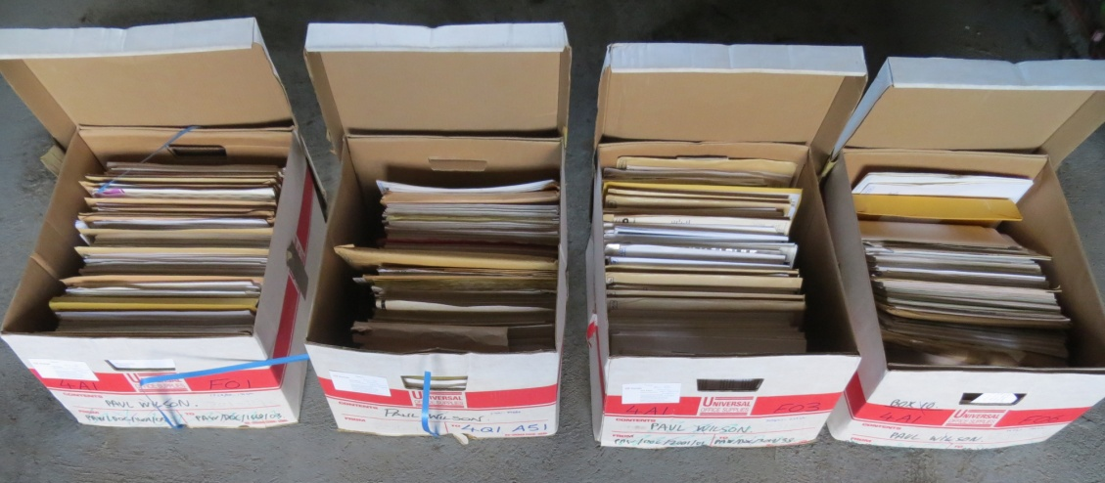
Figure 1 - The four boxes of Job documents that have yet to be scanned
Of the X paper originals (comprising some Y thousand pages) that have already been reviewed as part of the digitisation process, 344 of them (comprising some 11,300 pages) have been retained and are stored in three boxes as shown in Figure 2.
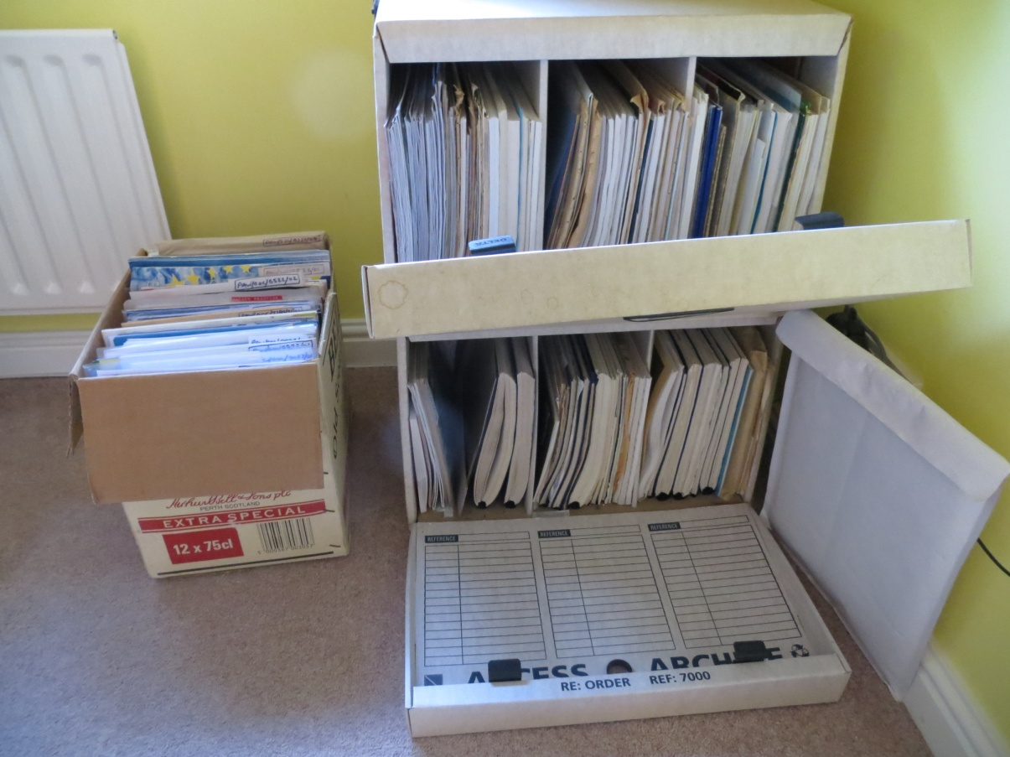
Figure 2 - The three boxes of retained Job documents
2.1.2 The Mementos collection
The Mementos collection is organised by each item having a reference number as described in section 2.1.1 above for the Job Documents collection. However the Mementos collection is not supported by Document Management software. Instead, it has an Index in an Excel spreadsheet and files of the digitised items are held in a single folder within the Windows file management system. The title of each electronic file starts with the reference number, thereby enabling a particular digitised document to be found by identifying the reference number in the Excel Index and then searching within the Windows folder.
Before the collection was organised and digitised it resided in folders in three boxes, as shown in Figure 3.
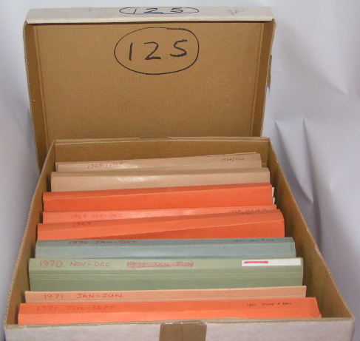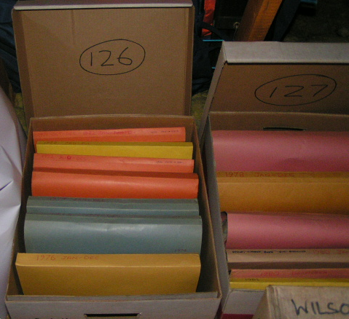
Figure 3 - The Mementos collection in three boxes prior to digitising
The originals that were retained after digitisation are stored in presentation folders and in the bottom shelf of a display cabinet as shown in Figure 4
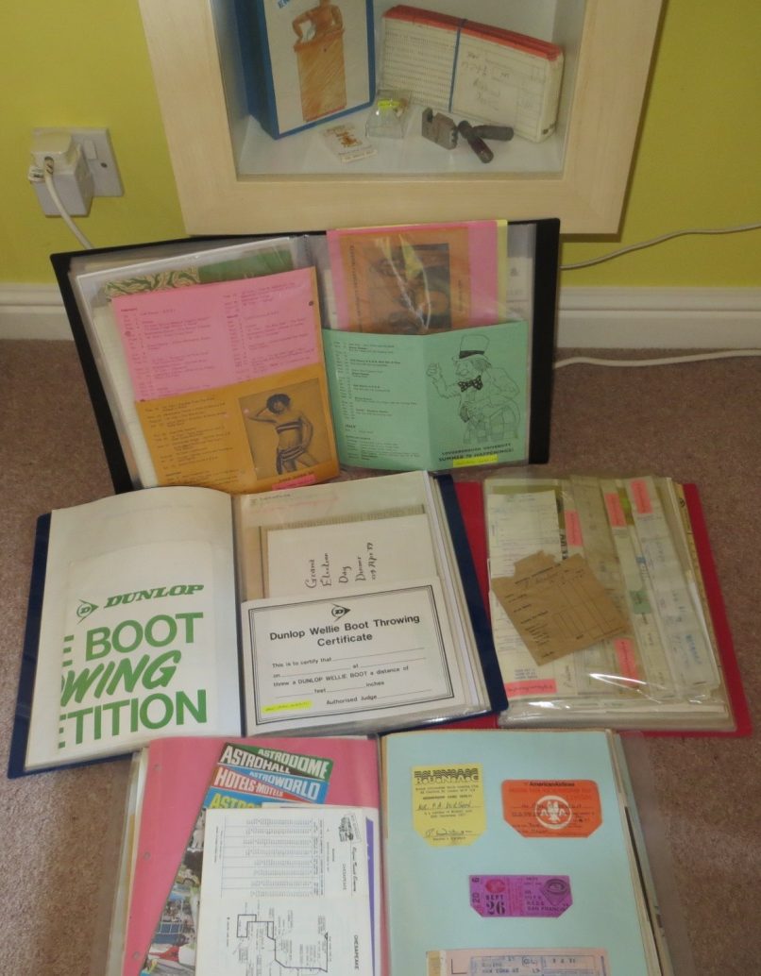
Figure 4 - The retained items in the Mementos collection
The organisation and digitisation process started in November 2012. In order to decide which items to include in the collection, and to try and understand why people keep mementos, a set of reasons for including items in the collection (‘Inclusion Criteria’) were developed. This was done by iteratively looking at example mementos and applying the criteria. The Inclusion Criteria that emerged are described below because there may be a relationship between Inclusion Criteria and Retention Criteria. The Inclusion Criteria that emerged identified three main perspectives:
- In the owner’s lifetime for use by the owner
- In the owner’s lifetime for use by others
- Later (i.e. after the owner has died)

Under each of these categories some or all of the following reasons might apply:
N – to help you not to forget
RM – to remind you
RF – as a reference for some information
P – because it’s associated with something you feel proud of
H- to pass family history on to your relations
S – because it’s too special to get rid of
U – because it’s very unusual and has novelty value

In addition, in the ‘Later’ category, options for advising those inheriting the item as to what to do with it were provided:
K – Keep
D - Destroy
KD - Keep or Destroy

During the organisation and digitisation process, a full record was kept of all the decisions made, and the reasons they were made, as each memento was assessed. The record was made in an Excel spreadsheet called “Wish Table” with the headings shown in Figure 5.
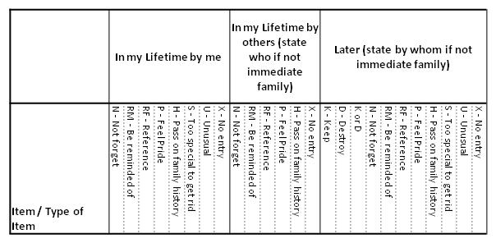
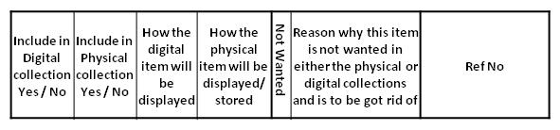
Figure 5 - Wish Table headings – the bottom group of cells go to the right of the top group in the spreadsheet

The Mementos collection contains a hugely diverse range of items reflecting the interests and activities of an individual over the period from when he was an 8 year old boy to a 30 year old man. It includes school calendars, school play programmes, exam papers, team sheets, sports programmes, membership cards, payslips, drill bits, tickets, theatre programmes, booklets of matches, scribbled notes, party invitations, cardboard novelties etc.. Much of it is paper-based – but some are physical artefacts such as the rejected drill bits from a holiday job as a lathe operator.
Of the overall Z items which were considered for the collection, X items were included in the collection, and, of those, Y items were retained in their original form.
2.2 The Studies
2.2.1 The Job Documents retain/destroy decision review study
This study will derive Draft PIM Retention Criteria (Draft PIMRC) by reviewing the set of previously compiled reasons why items in the Job Documents collection had been retained after being digitised. The digitisation of these documents started in 1995, and the ‘reasons for not destroying the paper’ (RFND) designations were made in September 2013. At the point when the RFND designations were made, there were some 344 retained items comprising some 11,300 pages as shown in Figure 2. When performing the RFND designation exercise, the owner had no knowledge of the NARS IV characteristics. Therefore, this exercise provides an opportunity to test the IV characteristics against a genuinely different point of view.
The analysis of RFND criteria was undertaken at the suggestion of Ann O’Brien as a precursor to starting work on a paper on “The artefact in the digital age”. A very rapid analysis was performed by assessing each of the retained documents in turn and making rough notes on why it had not been destroyed after digitisation. When all the items had been assessed, the notes were reviewed, similar notes grouped together, overlaps eliminated by either creating new groups or moving a reason between groups, doing a final refinement and finally defining each criteria in words. The final set of RFND criteria was then used to create a list of which criteria applied to each of the 344 retained items (the RFND item list). The nineteen categories of RFND criteria that emerged from this process are shown in Figure 6.

1 | You get a better appreciation of it if it’s on paper
2 | This is the original bit of paper which I might want to frame, bind, or just get the touch and feel of
3 | This is an A3 document which looks better on paper and I don't have an A3 printer
4 | Designed to be put to use in paper or laminated format
5 | Needs to be scanned in colour and at the time I didn't have a colour capability
6 | A booklet/newsletter which has a phyiscal look and feel which needs to be handled and flicked through to fully appreciate it and which you can't experience just by looking at the scanned image on screent
7 | Paper retained after scanning (or scanning put of till another day) because I thought I might want to make use of the document downstream or show it to others and would want to have it in paper form while I was using it
8 | Documents of some significance which are retained in their original form because it is only the actual artefact that can be claimed to be the actual item
9 | Documents which I believed to have particular significance at the time but don't any longer
10 | Published documents which mention myself or people I know
11 | Waiting for the PDF version to become available so that I can store that and destroy the paper version
12 | This is a large document which needs photographing to retain it as an integral document in digital format
13 | Legal dcoument for which I believe the original is required
14 | Needed to quickly file these and do the time consuming scanning job at a later date
15 | Documents which are of significance to myself and which I want to have a paper copy to hand to make it a more visible and tangible item
16 | Decision to scan these items was made after they had been included in the hardcopy box, but haven't got round to doing it yet
17 | Hardcopy retained until time can be found to separate items within it to be scanned and thrown away from artefacts to be retained
18 | Retained until I could do a 'really high quality' B&W scan
19 | Contains a diverse set of material which you wouldn't get the feel for if it was just scanned documents on a screen

Figure 6 - Reasons for not destroying the paper (RFND) criteria

Before undertaking the decision review study, the IV characteristics will be reviewed to ensure familiarity with each of the elements and their meanings. The decision review study will then be undertaken by placing each retained item on a desk in turn, reviewing its index entry, and recording on the RFND item list which, if any, of the IV characteristics were the reason(s) for it having been retained, and also noting any ‘other’ reasons for it being retained. The RFND criteria previously ascribed to each item will be hidden from view while this is taking place. When this exercise is complete, the following analysis and refinement process will be followed:
- The number of times each IV characteristic has been identified as a reason for retaining an item will be expressed as a percentage of the total number of retained items in this study.
- Each IV characteristic will be reviewed in turn to identify which items they have been applied to and which RFND criteria had been previously assigned to those items. This will provide an overall mapping of IV characteristics to RFND criteria.
- The ‘other’ reasons will then be reviewed, item by item, to identify which RFND criteria had been previously assigned to the item concerned. A significant difference may prompt an adjustment to the RFND criteria.
- The mapping of IV characteristics to RFND criteria identified in b) will then be adjusted to accommodate any adjustments to the RFND criteria made in c).
- For any IV characteristics which remain without a mapping to any RFND criteria in d), consideration will then be given to including them as extra elements in the RFND criteria.
- Final adjustments will then be made to the RFND criteria to try to achieve consistency, appropriate order, understandable names and clarity of the description language. The outcome will be the Draft PIM Retention Criteria (PIMRC).
- The RFND criteria previously assigned to each item will now be reviewed and replaced with the appropriate draft PIMRC element(s).
- The number of times each of the Draft PIMRC elements has been identified as a reason for retaining an item will be expressed as a percentage of the total number of items in this study.

2.2.2 The Job Documents digitisation study
This study will assess the effectiveness of the Draft PIMRC for making retain/destroy decisions for a contemporary document collection and will produce an Updated PIMRC. The documents concerned are those in the Job Documents collection which have yet to be digitised, and comprise 238 items consisting of Y pages as shown in Figure 1. Each item will be taken in turn, digitised and then assessed to decide whether to retain or destroy the paper originals. In order to gain additional knowledge about the applicability of the IV characteristics, each item will be assessed first against the IV characteristics and any that apply will be noted. The item will then be assessed against the draft PIMRC, and all those that apply will be noted. If there are any ‘other’ reasons for the physical item to be retained which don’t appear on the Draft PIMRC list, they also will be noted. When this process has been completed for all 238 items, the following analysis and refinement process will be followed:
- The number of times each IV characteristic has been identified as a reason for retaining an item will be expressed as a percentage of the total number of retained items in this study.
- The ‘other’ reasons will then be reviewed, item by item, to identify if any changes need to be made to the Draft PIMRC
- The Draft PIMRC will then be adjusted to accommodate all the required changes identified in b). This will produce the Updated PIMRC.
- The assignment of particular PIMRC elements as being reasons for retaining specific items, will be reviewed to accommodate the Updated PIMRC emerging from c).
- The number of times each of the Updated PIMRC has been identified as a reason for retaining an item will be expressed as a percentage of the total number of items that have been retained in this study.

2.2.3 The Memento retain/destroy decision review study
This study will assess the effectiveness of the Draft PIMRC for making retain/destroy decisions for a contemporary collection of mementos and will produce an Adjusted PIMRC. The mementos concerned are all those items in the Mementos collection as recorded in the Memento collection’s so-called Wish Table. Each item on the Wish Table will be considered in turn and those which have been retained will be assessed to establish the reasons for retention. In order to gain additional knowledge about the applicability of the IV characteristics, each retained item will first be assessed against the IV characteristics and any that apply will be noted. The item will then be assessed against the Draft PIMRC, and all those PIMRC elements that apply will be noted. If there are any ‘other’ reasons for the physical item being retained which don’t appear on the Draft PIMRC list, they also will be noted. When this process has been completed for all items, the analysis and refinement process described will be followed:
- The number of times each IV characteristic has been identified as a reason for retaining an item will be expressed as a percentage of the total number of retained items in this study.
- The ‘other’ reasons will then be reviewed, item by item, to identify if any changes need to be made to the Draft PIMRC.
- The Draft PIMRC will then be adjusted to accommodate all the required changes identified in b).
- The assignment of particular PIMRC elements as being reasons for retaining specific items, will be reviewed to accommodate the Adjusted PIMRC emerging from c).
- The number of times each of the Adjusted PIMRC elements has been identified as a reason for retaining an item will be expressed as a percentage of the total number of retained items in this study.
- Each of the items that were digitised but for which the original was discarded, will be reviewed using the Adjusted PIMRC to identify any Adjusted PIMRCs that apply and that would have prevented the original being discarded. The instances where this would have been the case will be noted.

2.2.4 Consolidation of the updated PIMRCs
Each of the three studies may produce slightly different PIMRC lists (the Draft PIMRC from the first study; the Updated PIMRC from the second study; and the Adjusted PIMRC from the third study). If so, this final exercise will consolidate them to accommodate all the differences into a Final PIMRC. Then, to enable a comparison to be made across all three studies, the allocation of reasons for retaining items in each study will be reviewed using the Final PIMRC. Using the revised allocations, the number of times each of the Final PIMRC elements has been identified as a reason for retaining an item in each study will be expressed as a percentage of the total number of items that have been retained in that particular study.
3 Findings
4 Discussion
5 Conclusions
6 References
Jones, W. (2007) Keeping Found Things Found: The Study and Practice of Personal Information Management. San Francisco, CA: Morgan Kaufmann Publishers. Cited on page(s) 3, 22, 25, 27, 39
McRanor, S. (1996) A critical analysis of intrinsic value. American Archivist, 59(4), 400-411.
Metters, Jane C. (2011) Digitization for Preservation and Effects on Intrinsic Value. A Master’s Paper for the M.S. in L.S. degree. 64 pages.
NARS, (1982) Intrinsic Value in Archival Material, Staff Information Paper Number 21, Web version at http://www.archives.gov/research/alic/reference/archives-resources/archival-material-intrinsic-value.html
Wilson (2000) 20 years in the life of a long-term empirical personal electronic filing study, Behaviour & Information Technology, 2001, Vol. 20, No. 5, 395-409

