IV in PIM: The applicability of Intrinsic Value in Personal Information Management
1. Introduction
Information Management is a term with strong associations with Computing. However, in practice, it is a topic which Librarians and those dealing with collections in general, have been dealing with for hundreds, if not thousands, of years. Personal Information Management, however, is a newer kid on the block, growing up within a fast expanding world of email, laptops, mobile phones, text messaging, tablets and social media systems. It is something that most of us grapple with, knowingly or unknowingly, everyday. Jones defines Personal Information Management (PIM) as referring to “both the practice and study of the activities a person performs in order to locate or create, store, organize, maintain, modify, retrieve, use and distribute information in each of its many forms (in various paper forms, in electronic documents, in email messages, in conventional Web pages, in blogs, in wikis, etc.) as needed to meet life’s many goals (everyday and long-term, work-related and not) and to fulfill life’s many roles and responsibilities (as parent, spouse, friend, employee, member of community, etc.)” (Jones, 2007)
Much of the information that we deal with today is electronic, however, a significant percentage starts out in a physical form which we then digitise to reap the advantages of improved organisation, search, retrieval and interrogation afforded by modern computer systems. For example, old photographs and paper documents can be digitised using a scanner; and we can take digital photographs of physical objects. At the point of digitisation, however, sometimes a dilemma arises (often because of a shortage of physical space): should we retain or destroy the original?
It was to answer a similar question that the US National Archives and Records Service (NARS) formed a Committee on Intrinsic Value in 1979 following a request by the General Services Administration (GSA) to microfilm all its records and destroy the originals. NARS felt compelled to "rebut the assumption that all records were disposable,"(McRanor, 1996). The report it produced defines Intrinsic Value to be “the archival term that is applied to permanently valuable records that have qualities and characteristics that make the records in their original physical form the only archivally acceptable form for preservation”. It goes on to identify the following nine qualities or characteristics, the possession of any one of which denotes that a record has Intrinsic Value (NARS, 1982):
- Physical form that may be the subject for study if the records provide meaningful documentation or significant examples of the form
- Aesthetic or artistic quality
- Unique or curious physical features
- Age that provides a quality of uniqueness
- Value for use in exhibits
- Questionable authenticity, date, author, or other characteristic that is significant and ascertainable by physical examination
- General and substantial public interest because of direct association with famous or historically significant people, places, things, issues, or events
- Significance as documentation of the establishment or continuing legal basis of an agency or institution
- Significance as documentation of the formulation of policy at the highest executive levels when the policy has significance and broad effect throughout or beyond the agency or institution
The NARS document was a significant report for Archivists since it came at the start of an era when the combination of rapidly improving digitisation hardware and software, and plummeting costs, made digitisation an increasingly desirable option for Archivists to consider. However, anecdotal evidence suggests that the NARS criteria may not be widely used in any kind of rigorous way. For example, in interviews with nine archivists and Libararians it was found that, while most were familiar with NARA’s definition of intrinsic value, most of them have their own loose definitions of the concept of Intrinsic Value which they apply when appraising items. (Metters, 2011).
Within the PIM arena, it is possible that the same will be true – individuals may not want to follow retention guidelines rigorously; though having such guidance may be of general assistance to either develop their own views and/or to inform their own views when appraising items. However, the author has been unable to find guidance similar to that found in the NARS report. Therefore, it would seem sensible not to re-invent the wheel, but instead to see if the notion of Intrinsic Value from the Archival domain can be usefully and effectively employed within the PIM domain. This paper, then, sets out to answer the following questions:
- Are the NARS Intrinsic Value characteristics applicable within the PIM domain?
- Do the NARS Intrinsic Value characteristics need adjusting in any way to enable them to be used effectively within the PIM domain?
- What set of Retain/Destroy Criteria would be most useful in the PIM domain? By implication, this set of criteria also provides an answer to the question “Why do people keep things in the PIM domain” from the point of view of one individual.
To explore these questions the paper will consider the retain/destroy decisions made by one of the authors for two of his personal collections – a ‘Job Documents’ collection and a collection of ‘Mementos’. The aim is to provide insights which can be used to inform subsequent, wider, more generalisable studies by other researchers.
2. Method
The investigation will make use of two sets of material: a collection of job documents built up over the last 40 years and comprising mainly paper originals but including a significant number of items that originated in electronic form; and a collection of personal mementos from the period 1958 – 1972 comprising mainly paper items but also including some physical objects. Both collections have been digitised by scanning or photographing the paper originals, and by photographing the objects. However, while the digitisation work has been completed for the Mementos collection, approximately 5% of the Job Documents collection has yet to be digitised.
Three studies of retain/destroy decisions will be made across the two collections. First, for the Job Documents, a previous categorisation of ‘Reasons for not destroying the paper’ (RFND criteria), made before the owner was aware of the NARS Intrinsic Value report, will be compared with the NARS Intrinsic Value (IV) characteristics and a draft set of PIM Retention Criteria (PIMRC) will be derived from the results. The second and third studies will refine the draft PIMRC by using them to make retain/destroy decisions in the Job Documents collection and the Mementos collection respectively. The studies will be performed by the owner of the two collections, who was responsible for deciding what to include in the collections in the first place, and for all the retain/destroy decisions that have been made prior to the start of the studies. Therefore, while the results of the studies will be based on a highly knowledgeable view of the material being investigated, they will nevertheless reflect the views of just one single individual.
2.1 The collections
2.1.1 The Job Documents collection
The Job Documents collection is organised by each document having a reference number comprising an Owner Identifier (for example, PAW); a Set identifier (for example, DOC); a serial number (for example, 3010) and a sub-serial number (for example, 01). So, a typical reference number looks like this: PAW/DOC/3010/01. The purpose of the serial number is to enable new documents to be given the next number on the list, i.e. the number signifies nothing other than the physical location of the document in the file. The purpose of the sub-serial number is to enable two or more documents to be kept physically together in a file if thought appropriate by the owner. Numbers are written in blue felt tip pen at the top right hand corner of physical documents. Each document in the collection is given an entry in an Index held in a Filemaker database. Digitised versions of documents are held in a Document Management System called Fish (supplied by a UK company called M-Hance). The Index is integrated with the Document Management System by way of control key combinations which, when selected within Filemaker, copy specified information on the screen, import it into Fish and enact a Fish action such as searching for a document or creating a new entry (Wilson, 2000). The Index and digitised documents are held on a laptop. The paper documents are held in file boxes – three boxes of retained documents, and four boxes of documents that have yet to be digitised.
At the beginning of August 2012, the overall collection comprised approximately 17060 separate Index entries, comprising some Y paper pages and Z electronic files (note that each digitised page has its own file in the Document Management System, i.e. a twenty page document when digitised would have twenty separate electronic files).
The collection contains a very diverse range of material including memos, reports, manuals, working papers, presentations, meeting minutes, publications, articles, standards documents, brochures, marketing material, travel documents, maps, conference materials etc.. They reflect the working life of the owner in the topic he got a degree in (Ergonomics and Human Factors), in the area in which the owner worked (Information Technology), and in the four organisations he was employed.
Digitisation of the paper originals started in 1995, some fourteen years after the collection was initiated. As at the start of this study, all of the paper originals have been scanned apart from four boxes (comprising some X thousand pages) as shown in Figure 1.
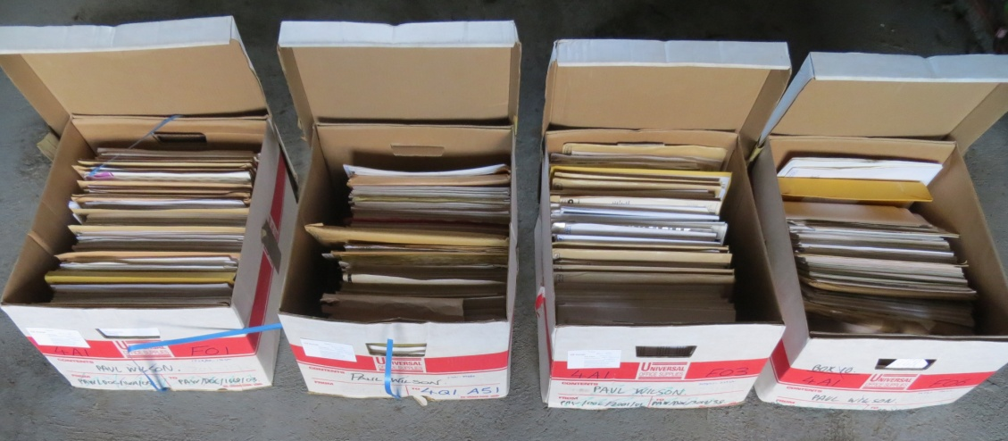
Figure 1 - The four boxes of Job documents that have yet to be scanned
Of the X paper originals (comprising some Y thousand pages) that have already been reviewed as part of the digitisation process, 344 of them (comprising some 11,300 pages) have been retained and are stored in three boxes as shown in Figure 2.
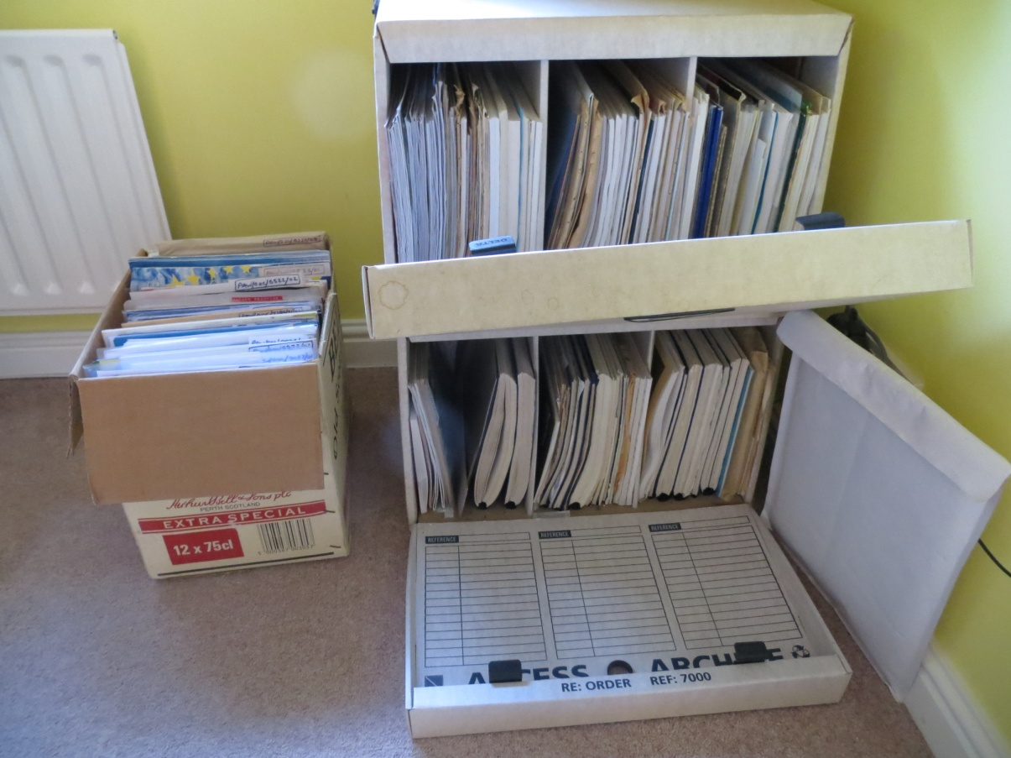
Figure 2 - The three boxes of retained Job documents
2.1.2 The Mementos collection
The Mementos collection is organised by each item having a reference number as described in section 2.1.1 above for the Job Documents collection. However the Mementos collection is not supported by Document Management software. Instead, it has an Index in an Excel spreadsheet and files of the digitised items are held in a single folder within the Windows file management system. The title of each electronic file starts with the reference number, thereby enabling a particular digitised document to be found by identifying the reference number in the Excel Index and then searching within the Windows folder.
Before the collection was organised and digitised it resided in folders in three boxes, as shown in Figure 3.
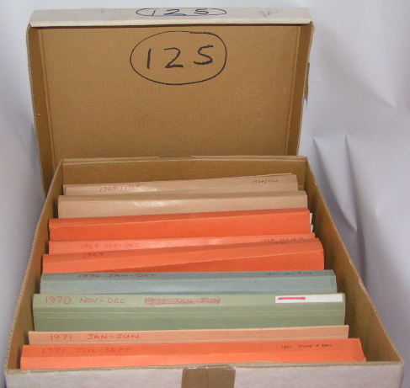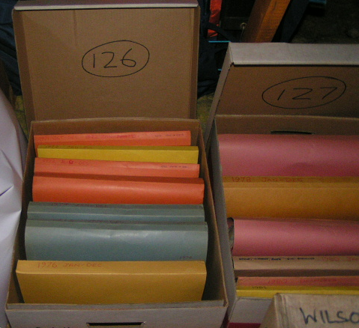
Figure 3 - The Mementos collection in three boxes prior to digitising
The originals that were retained after digitisation are stored in presentation folders and in the bottom shelf of a display cabinet as shown in Figure 4
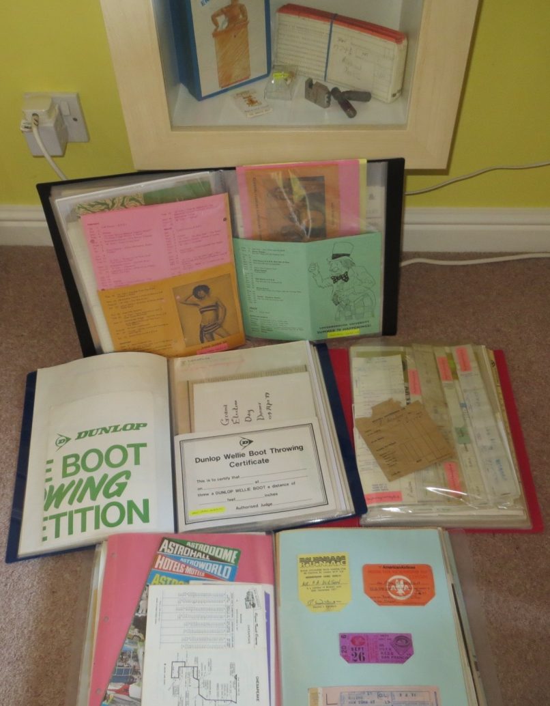
Figure 4 - The retained items in the Mementos collection
The organisation and digitisation process started in November 2012. In order to decide which items to include in the collection, and to try and understand why people keep mementos, a set of reasons for including items in the collection (‘Inclusion Criteria’) were developed. This was done by iteratively looking at example mementos and applying the criteria. The Inclusion Criteria that emerged are described below because there may be a relationship between Inclusion Criteria and Retention Criteria. The Inclusion Criteria that emerged identified three main perspectives:
- In the owner’s lifetime for use by the owner
- In the owner’s lifetime for use by others
- Later (i.e. after the owner has died)

Under each of these categories some or all of the following reasons might apply:
N – to help you not to forget
RM – to remind you
RF – as a reference for some information
P – because it’s associated with something you feel proud of
H- to pass family history on to your relations
S – because it’s too special to get rid of
U – because it’s very unusual and has novelty value

In addition, in the ‘Later’ category, options for advising those inheriting the item as to what to do with it were provided:
K – Keep
D - Destroy
KD - Keep or Destroy

During the organisation and digitisation process, a full record was kept of all the decisions made, and the reasons they were made, as each memento was assessed. The record was made in an Excel spreadsheet called “Wish Table” with the headings shown in Figure 5.
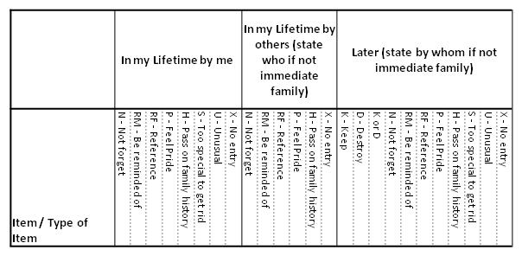
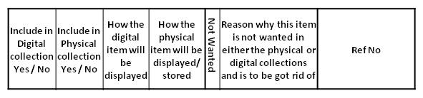
Figure 5 - Wish Table headings – the bottom group of cells go to the right of the top group in the spreadsheet

The Mementos collection contains a hugely diverse range of items reflecting the interests and activities of an individual over the period from when he was an 8 year old boy to a 30 year old man. It includes school calendars, school play programmes, exam papers, team sheets, sports programmes, membership cards, payslips, drill bits, tickets, theatre programmes, booklets of matches, scribbled notes, party invitations, cardboard novelties etc.. Much of it is paper-based – but some are physical artefacts such as the rejected drill bits from a holiday job as a lathe operator.
Of the overall Z items which were considered for the collection, X items were included in the collection, and, of those, Y items were retained in their original form.
2.2 The Studies
2.2.1 The Job Documents retain/destroy decision review study
This study will derive Draft PIM Retention Criteria (Draft PIMRC) by reviewing the set of previously compiled reasons why items in the Job Documents collection had been retained after being digitised. The digitisation of these documents started in 1995, and the ‘reasons for not destroying the paper’ (RFND) designations were made in September 2013. At the point when the RFND designations were made, there were some 344 retained items comprising some 11,300 pages as shown in Figure 2. When performing the RFND designation exercise, the owner had no knowledge of the NARS IV characteristics. Therefore, this exercise provides an opportunity to test the IV characteristics against a genuinely different point of view.
The analysis of RFND criteria was undertaken at the suggestion of Ann O’Brien as a precursor to starting work on a paper on “The artefact in the digital age”. A very rapid analysis was performed by assessing each of the retained documents in turn and making rough notes on why it had not been destroyed after digitisation. When all the items had been assessed, the notes were reviewed, similar notes grouped together, overlaps eliminated by either creating new groups or moving a reason between groups, doing a final refinement and finally defining each criteria in words. The final set of RFND criteria was then used to create a list of which criteria applied to each of the 344 retained items (the RFND item list). The nineteen categories of RFND criteria that emerged from this process are shown in Figure 6.

1 | You get a better appreciation of it if it’s on paper
2 | This is the original bit of paper which I might want to frame, bind, or just get the touch and feel of
3 | This is an A3 document which looks better on paper and I don't have an A3 printer
4 | Designed to be put to use in paper or laminated format
5 | Needs to be scanned in colour and at the time I didn't have a colour capability
6 | A booklet/newsletter which has a phyiscal look and feel which needs to be handled and flicked through to fully appreciate it and which you can't experience just by looking at the scanned image on screent
7 | Paper retained after scanning (or scanning put of till another day) because I thought I might want to make use of the document downstream or show it to others and would want to have it in paper form while I was using it
8 | Documents of some significance which are retained in their original form because it is only the actual artefact that can be claimed to be the actual item
9 | Documents which I believed to have particular significance at the time but don't any longer
10 | Published documents which mention myself or people I know
11 | Waiting for the PDF version to become available so that I can store that and destroy the paper version
12 | This is a large document which needs photographing to retain it as an integral document in digital format
13 | Legal dcoument for which I believe the original is required
14 | Needed to quickly file these and do the time consuming scanning job at a later date
15 | Documents which are of significance to myself and which I want to have a paper copy to hand to make it a more visible and tangible item
16 | Decision to scan these items was made after they had been included in the hardcopy box, but haven't got round to doing it yet
17 | Hardcopy retained until time can be found to separate items within it to be scanned and thrown away from artefacts to be retained
18 | Retained until I could do a 'really high quality' B&W scan
19 | Contains a diverse set of material which you wouldn't get the feel for if it was just scanned documents on a screen

Figure 6 - Reasons for not destroying the paper (RFND) criteria

Before undertaking the decision review study, the IV characteristics will be reviewed to ensure familiarity with each of the elements and their meanings. The decision review study will then be undertaken by placing each retained item on a desk in turn, reviewing its index entry, and recording on the RFND item list which, if any, of the IV characteristics were the reason(s) for it having been retained, and also noting any ‘other’ reasons for it being retained. The RFND criteria previously ascribed to each item will be hidden from view while this is taking place. When this exercise is complete, the following analysis and refinement process will be followed:
- The number of times each IV characteristic has been identified as a reason for retaining an item will be expressed as a percentage of the total number of retained items in this study.
- Each IV characteristic will be reviewed in turn to identify which items they have been applied to and which RFND criteria had been previously assigned to those items. This will provide an overall mapping of IV characteristics to RFND criteria.
- The ‘other’ reasons will then be reviewed and considered alongside the IV characteristics and the RFND criteria in order to derive a set of Draft PIM Retention Criteria (PIMRC). For completeness, all IV characteristics will be included in the Draft PIMRC in some form or other – even if no instances of the use of particular characteristics were identified in the study. If no instances of those items are identified in any of the three studies, such items may be excluded from the Final PIMRC list to be derived at the end of the work.
- One or more Draft PIM Retention Criteria will be assigned to each of the items in the study.
- The number of times each of the Draft PIMRC elements has been identified as a reason for retaining an item will be expressed as a percentage of the total number of items in this study.

2.2.2 The Job Documents digitisation study
This study will assess the effectiveness of the Draft PIMRC for making retain/destroy decisions for a contemporary document collection and will produce an Updated PIMRC. The documents concerned are those in the Job Documents collection which have yet to be digitised, and comprise 238 items consisting of Y pages as shown in Figure 1. Each item will be taken in turn, digitised and then assessed against the draft PIMRC to decide whether to retain or destroy the paper originals, and all those that PIMRC elements that apply will be noted. If there are any ‘other’ reasons for the physical item to be retained which don’t appear on the Draft PIMRC list, they also will be noted. When this process has been completed for all 238 items, the following analysis and refinement process will be followed:
- The number of times each IV characteristic or its equivalent in the Draft PIMRC, has been identified as a reason for retaining an item will be expressed as a percentage of the total number of retained items in this study.
- The ‘other’ reasons will then be reviewed, item by item, to identify if any changes need to be made to the Draft PIMRC
- The Draft PIMRC will then be adjusted to accommodate all the required changes identified in b). This will produce the Updated PIMRC.
- The assignment of particular PIMRC elements as being reasons for retaining specific items, will be reviewed to accommodate the Updated PIMRC emerging from c).
- The number of times each of the Updated PIMRC has been identified as a reason for retaining an item will be expressed as a percentage of the total number of items that have been retained in this study.

2.2.3 The Memento retain/destroy decision review study
This study will assess the effectiveness of the Draft PIMRC for making retain/destroy decisions for a contemporary collection of mementos and will produce an Adjusted PIMRC. The mementos concerned are all those items in the Mementos collection as recorded in the Memento collection’s so-called Wish Table. Each item on the Wish Table will be considered in turn and those which have been retained will be assessed against the Draft PIMRC to establish the reasons for retention, and all those PIMRC elements that apply will be noted. If there are any ‘other’ reasons for the physical item being retained which don’t appear on the Draft PIMRC list, they also will be noted. When this process has been completed for all items, the analysis and refinement process described will be followed:
- The number of times each IV characteristic has been identified as a reason for retaining an item will be expressed as a percentage of the total number of retained items in this study.
- The ‘other’ reasons will then be reviewed, item by item, to identify if any changes need to be made to the Draft PIMRC.
- The Draft PIMRC will then be adjusted to accommodate all the required changes identified in b).
- The assignment of particular PIMRC elements as being reasons for retaining specific items, will be reviewed to accommodate the Adjusted PIMRC emerging from c).
- The number of times each of the Adjusted PIMRC elements has been identified as a reason for retaining an item will be expressed as a percentage of the total number of retained items in this study.
- Each of the items that were digitised but for which the original was discarded, will be reviewed using the Adjusted PIMRC to identify any Adjusted PIMRCs that apply and that would have prevented the original being discarded. The instances where this would have been the case will be noted.

2.2.4 Consolidation of the updated PIMRCs
Each of the three studies may produce slightly different PIMRC lists (the Draft PIMRC from the first study; the Updated PIMRC from the second study; and the Adjusted PIMRC from the third study). If so, this final exercise will consolidate them to accommodate all the differences into a Final PIMRC. Then, to enable a comparison to be made across all three studies, the allocation of reasons for retaining items in each study will be reviewed using the Final PIMRC. Using the revised allocations, the number of times each of the Final PIMRC elements has been identified as a reason for retaining an item in each study will be expressed as a percentage of the total number of items that have been retained in that particular study.
3 Findings
3.1 Findings from the Job Documents retain/destroy decision review study
3.1.1 IV characteristics Usage
The number of times each IV characteristic was identified as being the reason for retaining an item is shown below:
IV Characteristic | Number of times cited (out of 344 possible times) | Percentage used
1. Physical form | 5 | 1.5
2. Aesthetic quality | 1 | 0.3
3. Physical features | 15 | 4.4
4. Age | 6 | 1.7
5. Use in exhibits | 1 | 0.6
6. To answer authenticity Questions | 0 | 0
7. Significant links | 39 | 11.3
8. Legality of an institution | 0 | 0
9. Executive policy document | 1 | 0.3

3.1.2 Mapping of IV characteristics to RFND criteria
The each instance of an IV characteristic being cited as a reason for retention, the RFND criteria previously recorded for the item is listed below:

IV Characteristic | Number of times cited | RFND criteria previously assigned to the item concerned | Number of times this RFND was cited
1. Physical form | 5 | 15. To make it a more visible/ tangible  4. For use as paper or laminate  BOTH 8. Significant item - original required AND 15. To make it a more visible/tangible | 2  2  1
2. Aesthetic quality | 1 | 8. Significant item - original required | 1
3. Physical features | 14 | 4. For use as paper or laminate  BOTH 4. For use as paper or laminate AND 5. Needs colour - no colour scanner  BOTH 4. For use as paper or laminate AND 12. Large doc needs photographing  ALL OF 4. For use as paper or laminate AND 8. Significant item - original required AND 15. To make it a more visible/tangible  ALL OF 4. For use as paper or laminate AND 8. Significant item - original required AND 15. To make it a more visible/tangible  AND 6. Booklet/leaflet special look & feel  BOTH 9. Used to think this was significant AND 15. To make it a more visible/tangible  BOTH 6. Booklet/leaflet special look & feel AND 8. Significant item - original required | 8  1  1  1  1  1  1
4. Age | 6 | 8. Significant item - original required  12. Large doc needs photographing  15. To make it a more visible/tangible  BOTH 6. Booklet/leaflet special look & feel AND 8. Significant item - original required | 2  1  1  2
5. Use in exhibits | 1 | BOTH 4. For use as paper or laminate AND 12. Large doc needs photographing | 1
6. To answer authenticity Questions | 0 | None
7. Significant links | 39 | 4. For use as paper or laminate  6. Booklet/leaflet special look & feel  8. Significant item - original required  15. To make it a more visible/tangible  17. Sort needed before scanning  ALL OF 4. For use as paper or laminate AND 6. Booklet/leaflet special look & feel AND 8. Significant item - original required  BOTH 6. Booklet/leaflet special look & feel AND 8. Significant item - original required  ALL OF 6. Booklet/leaflet special look & feel AND 8. Significant item - original required  AND 15. To make it a more visible/tangible  BOTH 8. Significant item - original required AND 15. To make it a more visible/tangible | 2  1  20  1  1  2  6  5  1
8. Legality of an institution | 0 | None
9. Executive policy document | 1 | 8. Significant item - original required | 1

3.1.3 Derivation of draft PIMRC
The 313 ‘other’ reasons that were provided in the course of the first part of the study were reviewed and significant features of the items concerned and the reasons they were retained were noted. The notes were then used together with the RFND criteria, the IV characteristics, and the descriptions of the items concerned, to derive the Draft PIM Retention Criteria (PIMRC) as described below.
An immediate observation from a review of the 'other' comments was that several documents had been retained merely to delay the digitisation process for a variety of reasons. These included waiting for PDFs to become available; waiting until there was time to sort out a jumbled set of papers constituting one index entry; and waiting until equipment capable of scanning in colour became available. This Draft PIMRC can be generalised to 'Digitisation to be performed later'.

Of the documents that were actually digitised, the most tangible reasons for retaining the originals were to do with wanting to actually work with the documents. For example, manuals for a printer, wireless keyboard and scanner which the owner would prefer to put next to the equipment whilst troubleshooting them or setting them up; and an article on digitising cassette tapes which the owner would like to have immediately to hand as the digitising was being done. in similar vein are some documents which were retained in case the owner wanted to show someone their contents - such as the magazine that contained pictures of an impressive modern building in which he worked. Finally, there were the hard copy masters that had been retained to either lend to other people (such as a 1993 dissertation on the Job Documents collection) or to make copies of papers published by the owner to give to other people. Of course, all of these requirements could be met using the digital versions, however the owner made the choice to employ them in their original paper format. Since then, I believe my perception of whether a hard copy format is better to work with has changed - and will continue to change - as technology and the culture of its use develops. Owner’s will always have this choice to make with respect to items that are to be put to continued use. This retention criterion can be generalised to "Items to be put to work in their original form".

There were a number of items that were retained simply because of their uniqueness. These were signed certificates signifying some achievement; a software licence agreement; an agenda for a Training day signed by the inspirational speaker, the athlete Roger Black; and the originals of a wallet-based foldable paper diary descriptions of which were included in a published paper. In all these cases It was judged that it was necessary to retain the original to be able to prove their existence. This is equivalent to the IV characteristic “Questionable authenticity, date, author, or other characteristic that is significant and ascertainable by physical examination. However a modified title will be used - "Items for which only the originals confirm their validity".

Another category first presented itself in the form of the last edition of Business Systems & Equipment magazine, the first issue of e-Doc magazine (the successor to Document World magazine), and the first set of overhead slides that the owner ever produced with a presentation programme in 1987. Although the 'last' and 'first' criteria might seem clear cut, in fact the retention of the 1000th issue of the UK’s Computer Weekly (1986), and of the 5th issue of MacUser magazine of March 1996, seems to belie that notion. The Apple Macintosh world was somewhat niche back then, but those in the know already sensed that it was something special and exciting. Getting and reading an issue of MacUser reinforced that feeling, so a pristine issue - even if only the fifth issue - from that era was something worth retaining. Likewise, the retained Apple brochure for the Newton hand held machine, has a similar cache. In similar vein is the Guardian's 1994 personalised newspaper of the future, and it's 1995 supplement on a Non-User's Guide to the Internet. These items are a little unusual and although widely published are probably not that commonly available - a bit like trophies one might put on display. They perhaps come under the auspices of the IV characteristic “General and substantial public interest because of direct association with famous or historically significant people, places, things, issues or events”. Finally, one of the retained items was a printout of an email message saying that the recipient should regard the email it forwarded as a collector's piece. The forwarded email was from a senior manager confirming that a few days of this year's holiday could actually be carried forward to next year. It was a humorous message, sent by someone whose humour was always enjoyable to be about, and the very fact that the missive said it should be regarded as a collector's piece meant that it became so. Despite the fact that the original was electronic, the owner still printed out a version on paper thinking that, perhaps, one day, it could be framed or at least shown some to colleagues. It is the notion of collectability that seems to bind all these examples together. They are all special in their own way, and they have been retained simply to enable the owner to be reminded of, and to enjoy, what they represent. These are "Trophy items to be collected and enjoyed in the future".

Next come the large documents - many of them colour poster sized glossies such as a process flow representation of how company accounts work; a Personal Computer World double sider showing benchmark information for all personal computers in 1987 and with the benchmark algorithm that was used written in six different programming languages on the reverse; a table showing European email connectivity in 1995; and a year 2000 illustration of the way the Cast product discovers and represents the inner workings of software applications. At the time these were retained, it was practically impossible for the owner to digitise them effectively. Now, though, it's just a matter of photographing them with a modern digital camera and storing the JPG image. This means that, if the owner so desires, several A3 sized originals (including a hierarchical representation of Workgroup Computing projects underway, an e-business process flow, and an HCI component hierarchy) can now be digitised and destroyed. However, there is still a question concerning the viewing of the very large documents; can the full impact, integrity and viewing experience of a large document (A2 and bigger) be achieved when looking at them on a relatively smaller screen? Such issues also apply to broadsheet newspaper supplements such as the Financial Times' 1984 twenty page report on the Desk Top Revolution; and the Observer 1990 twelve page section on Mobile Communications. There is also one final issue which applies to all professionally printed and published publications - once they are destroyed the individual is unlikely to be able to reproduce anything like the look and feel and, for large documents, the size of the original. Whether one is willing to lose those qualities forever, is a particularly pertinent question at the point of digitisation. This retention criterion, then, is "Large documents which have particular qualities of impact and integrity".

Small publications, typically, but not exclusively, of A4 size or less, mirror these issues. Although they are easily scanned, to do so may require their bindings to be stretched or even dismembered, such that they may never regain their exact original form. Furthermore, it is unlikely that small publications printed on special papers and with stapled or glued spines, can be successfully recreated by a non-specialist from their digital copies. Examples encountered include a 1980 booklet on the Physiology of Hearing and the Impact of Noise; the UK Department of Trade & Industry's 1986 reports on the Office Automation Pilots; and US Robotics' 1993 Sportster Guide to On-Line Services. These types of publications form the criterion "Small publications of around A4 size or less with fixed spine bindings and/or special papers".

Up to this point, the items discussed have been publications with which the owner of the collection had had no prior involvement. However, an owner's association with an item does provide another set of possible reasons for retaining it. The first of these to be considered is the circumstance whereby a friend or colleague is either responsible for a publication or is mentioned within it. For example, the reprint of the Fortune magazine article on Doug Vogel's electronic meeting room in Arizona which the owner visited; and the front page of a 1989 issue of the UK MacUser magazine which included the photo of a friend. These impart a personal interest of the sort alluded to by the IV characteristic No 7 (General and substantial public interest because of direct association with famous or historically significant people, places, things, issues or events). The IV characteristic deals with public interest and famous people, whereas in the personal arena it is a personal interest in someone you know who is, de facto, 'famous' because of their appearance in the publication. It may not be an exact analogy, but, nevertheless, it is that sort of thinking that has resulted in these particular examples being retained in their original format. Of course, if a publication mentions oneself, the individual concerned is likely to have an even greater interest and commensurate desire to retain the original - even if it is only an extract from the publication such as a newspaper cutting. These types of items constitute the "Publications which mention friends, colleagues or the owner" criterion

An individual might also feel an emotional attachment to publications that are produced by the organisation they work for. This could be on any number of subjects, for example, a business update, a product guide, and a newsletter. The latter is a particularly good example since it often has some information of direct relevance to the individual and may well mention, or even include, photos of colleagues or themselves. Having said that, one of the newsletters in this collection started to be simultaneously published in electronic (PDF) format, and from then on the owner stopped retaining the hardcopy. This indicates that, when an official version that is designed for use on screen is produced, the desire to retain hardcopies may be diminished. Closely related to publications produced by one’s employer is the programme or project that an individual participates in. In this study, the owner was heavily involved in the Alvey Cosmos (Configurable Structured Message System) project, and the Hicom HCI conferencing system, and consequently retained many of the Cosmos and Hicom documents and publications in their original form. All of these types of materials constitute the criterion "Items published by an organisation or programme that the owner works/worked for".

Above and beyond the organisation’s publications, however, it is the things that people produce themselves that they often value the most. Documents or reports or papers that they have jointly or solely authored - particularly if they are in any way creative, innovative or strategic - are often things that individuals are proud of and may want to retain. If the item is published to even only one or two people, then individuals will be likely to want to retain the original in its published form. Some examples in this collection are NCC’s 1981 Management Guideline No 67 on Designing systems for people; the 1984 issue of Design Studies in which the paper 'Towards the electronic pocket diary' appears; all 6 issues of the Cosmos Information Exchange Newsletter from the late 1980s; and a paper and presentation on ‘Controlled development of systems in a rapidly changing world’ produced for an interview in 1992. There are also instances of documents and sets of documents, that weren't published as such, but which the owner created or assembled and which were valued sufficiently to be retained, for example, all the documents provided during a three day Systems Acquaintance course at Kodak in 1973; and a spiral bound sets of reports of visits to different organisations in the course of Office Automation projects in the 1980s. All such items are "Items that the owner has written, produced, assembled or made a significant contribution to".

With the exception of large documents, most of the types of items previously described can be viewed successfully in their digital form on a display screen. However, there are some items which have a physical construction which is difficult, if not impossible, to digitise and replicate the experience of interacting with the physical item. Such items are also likely to be very difficult to reconstruct once again from their digital copies so that when the original is destroyed it is effectively gone for good. These are clear candidates for retaining in their original form. Examples of such items encountered in this study include the 1982 BLEND project's user guide with progressively longer pages to enable different sections to be turned to from the front of the document; the 1991 rectangular packet containing the Nautilus Intro CD, with fold outs from three of the sides of the rectangle and one of those sides containing four quarter-segments hinged at the edge so that they can be splayed out; instances of the foldable paper diary I carried in my wallet in the early 80s to explore the concept of the personal electronic diary; and several examples of laminated cue cards and checklists. Interestingly, a number of instances of photos were also encountered in this study and it is thought that they were kept because, at the time they were retained, it wasn't that easy to reproduce photographs at will on ordinary home computer equipment. That is not the case today, though individuals may still feel that the physical composition of a photo - special photographic paper or a particular size - might merit its retention. All these sorts of items map closely onto the IV characteristic "Unique or curious physical features", though the retention rationale is slightly different. In the IV case, it is the unusualness of the physical features that provides a reason for retaining items, whereas in the PIM domain it is difficulties in scanning, in replicating an equivalent interaction experience on screen, and in reconstructing the item from the digital copy, that constitute the retention rationale. Consequently, the IV terminology will not be used and instead this criterion will be named "Physical features which make it difficult to digitise the item and/or to reconstruct it from the digital copy".

A few items exhibited another physical characteristic – their formats were examples of technological developments. For example, a book review from the early 80s for the BLEND electronic journal project produced on a printout from the teletype which was used to participate in the project; and a 1994 Guardian personalised news sheet of the future produced on a very tough material called Tyvek. This category is covered in the IV characteristics as “Physical form that may be the subject for study if the records provide meaningful documentation or significant examples of the form. A modified title will be used here – “Items illustrating a physical form due to a development in technology”.

Two items encountered in this study suggest that the IV characteristic "Age that provides a quality of uniqueness" was at least part of the reason for retaining them. One was a handwritten talk on the history of computing in government produced for the owner's university course in 1971; and the other is a single page from the early 1990s, very worn and raggedy, completely filled with contact names and phone numbers in very small writing. As the IV description makes clear, 'Age can be a factor even with comparatively recent records'. In the case of the handwritten talk it was the fact that It came from an era long ago in the individual's life, and in the case of the raggedy contact list it was the heavy use over a long period of time, that provided the retention rationale. Since the IV characteristic is an exact match to the equivalent criteria in the PIM domain, the IV name will be employed here.

Finally, just one item was encountered which explicitly forbade copying. It was a four page, A4 foldout questionnaire called Strength Deployment Inventory which was intended to be filled in and retained by the individual, and had a big bold message down the side saying “Making copies of this material by any method is a violation of copyright law”. This criterion is “Copying explicitly prevented by copyright”.

This concludes the derivation of criteria from review of the ‘other’ comments and from the items in the collection under study. Next, the IV characteristics and RDFN criteria will be reviewed to identify any additional criteria that need to be added. The table below summarises the results of this analysis.

IV characteristic or RFDN criterion | Action to be taken | New criteria to be included in the Draft PIMRC
IV
1. Physical form that may be the subject for study if the records provide meaningful documentation or significant examples of the form | Already in Draft PIMRC as “Items illustrating a physical form due to a development in technology”. | None
2. Aesthetic or artistic quality | One item identified in this study - include in Draft PIMRC | Include with IV terminology – “Aesthetic or artistic quality”
3. Unique or curious physical features | Already in Draft PIMRC as “Physical features which make it difficult to digitise the item and/or to reconstruct it from the digital copy” | None
4. Age that provides a quality of uniqueness | Already in Draft PIMRC with same name as IV characteristic | None
5. Value for use in exhibits | No items identified in this study but may be encountered in PIM - include in Draft PIMRC | Include with slightly modified IV terminology – “For use in exhibits”
6. Questionable authenticity, date, author, or other characteristic that is significant and ascertainable by physical examination | Already in Draft PIMRC as “Items for which only the originals confirm their validity” | None
7. General and substantial public interest because of direct association with famous or historically significant people, places, things, issues, or events | Already covered in Draft PIMRC as “Trophy items to be collected and enjoyed in the future". | None
8. Significance as documentation of the establishment or continuing legal basis of an agency or institution | Unlikely to be encountered in PIM – but include in the Draft PIMRC for completeness. | Include with modified IV terminology – “Item relating to the legality of an institution”
9. Significance as documentation of the formulation of policy at the highest executive levels when the policy has significance and broad effect throughout or beyond the agency or institution | A few items were identified in this study - include in Draft PIMRC | Include with modified IV terminology – “Executive Policy document”
RDFN Criteria
1.You get a better appreciation of it if it’s on paper | Already included in Draft PIMRC as “Large documents which have particular qualities of impact and integrity” and “Physical features which make it difficult to digitise the item and/or to reconstruct it from the digital copy” | None
2.This is the original bit of paper which I might want to frame, bind, or just get the touch and feel of | Already included in Draft PIMRC as “Items for which only the originals confirm their validity” | None
3.This is an A3 document which looks better on paper and I don't have an A3 printer | Already included in Draft PIMRC as “Large documents which have particular qualities of impact and integrity” | None
4.Designed to be put to use in paper or laminated format | Already included in Draft PIMRC as “Items to be put to work in their original form” | None
5. Needs to be scanned in colour and at the time I didn't have a colour capability | Already included in Draft PIMRC as “Digitisation to be performed later” | None
6. A booklet/newsletter which has a physical look and feel which needs to be handled and flicked through to fully appreciate it and which you can't experience just by looking at the scanned image on screen | Already included in Draft PIMRC as “Small publications of around A4 size or less with fixed spine bindings and/or special papers” | None
7.Paper retained after scanning (or scanning put of till another day) because I thought I might want to make use of the document downstream or show it to others and would want to have it in paper form while I was using it | Already included in Draft PIMRC as “Items to be put to work in their original form” | None
8.Documents of some significance which are retained in their original form because it is only the actual artefact that can be claimed to be the actual item | Already included in Draft PIMRC as “Items for which only the originals confirm their validity”. | None
9.Documents which I believed to have particular significance at the time but don't any longer | Such a criteria is not useful for initial digitisation decisions – exclude from Draft PIMRC. | None
10.Published documents which mention myself or people I know | Already included in Draft PIMRC as “Publications which mention, friends, colleagues or the owner” | None
11.Waiting for the PDF version to become available so that I can store that and destroy the paper version | Already included in Draft PIMRC as “Digitisation to be performed later”. | None
12.This is a large document which needs photographing to retain it as an integral document in digital format | Already included in Draft PIMRC as “Large documents which have particular qualities of impact and integrity”. | None
13.Legal document for which I believe the original is required | Already included in Draft PIMRC as “Items for which only the originals confirm their validity”. | None
14.Needed to quickly file these and do the time consuming scanning job at a later date | Already included in Draft PIMRC as “Digitisation to be performed later”. | None
15.Documents which are of significance to myself and which I want to have a paper copy to hand to make it a more visible and tangible item | Already covered in Draft PIMRC by several of the criteria. | None
16.Decision to scan these items was made after they had been included in the hardcopy box, but haven't got round to doing it yet | Already included in Draft PIMRC as “Digitisation to be performed later”. | None
17.Hardcopy retained until time can be found to separate items within it to be scanned and thrown away from artefacts to be retained | Already included in Draft PIMRC as “Digitisation to be performed later”. | None
18.Retained until I could do a 'really high quality' B&W scan | Already included in Draft PIMRC as “Digitisation to be performed later”. | None
19.Contains a diverse set of material which you wouldn't get the feel for if it was just scanned documents on a screen | Already included in Draft PIMRC as “Items that the owner has written, produced, assembled or made a significant contribution to” and  “Physical features which make it difficult to digitise the item and/or to reconstruct it from the digital copy” | None

All of the Retention Criteria that were identified earlier in this section are listed below. The list constitutes the Draft PIMRC that will be used in the second and third studies reported in this paper.

- Digitisation to be performed later
- Items to be put to work in their original form
- Items for which only the originals confirm their validity
- Trophy items to be collected and enjoyed in the future.
- Large documents which have particular qualities of impact and integrity.
- Small publications of around A4 size or less with fixed spine bindings and/or special papers
- Publications which mention friends, colleagues or the owner
- Items published by an organisation or programme that the owner works/worked for
- Items that the owner has written, produced, assembled or made a significant contribution to
- Physical features which make it difficult to digitise the item and/or to reconstruct it from the digital copy
- Items illustrating a physical form due to a development in technology
- Age that provides a quality of uniqueness
- Copying explicitly prevented by copyright
- Aesthetic or artistic quality
- For use in exhibits
- Item relating to the legality of an institution
- Executive Policy document

3.1.4 Draft PIMRC usage
The Draft PIMPRC were assigned to each of the items in the study, and the number of times each Draft PIMRC was identified as being the reason for retaining an item is shown below:
Draft PIMRC | Number of times cited (out of 344 possible times) | Percentage used
- Digitisation to be performed later | 50 | 14.8
- Items to be put to work in their original form | 20 | 5.8
- Items for which only the originals confirm their validity | 5 | 1.5
- Trophy items to be collected and enjoyed in the future. | 17 | 4.9
- Large documents which have particular qualities of impact and integrity. | 29 | 8.4
- Small publications of around A4 size or less with fixed spine bindings and/or special papers | 127 | 36.9
- Publications which mention, friends, colleagues or the owner | 7 | 2
- Items published by an organisation or programme that the owner works/worked for | 100 | 29.1
- Items that the owner has written, produced, assembled or made a significant contribution to | 81 | 23.5
- Physical features which make it difficult to digitise the item and/or to reconstruct it from the digital copy | 12 | 3.5
- Items illustrating a physical form due to a development in technology | 6 | 1.7
- Age that provides a quality of uniqueness | 7 | 2
- Copying explicitly prevented by copyright | 1 | 0.3
- Aesthetic or artistic quality | 1 | 0.3
- For use in exhibits | 0 | 0
- Item relating to the legality of an institution | 0 | 0
- Executive Policy document | 4 | 1.2

4 Discussion
- The IV perspective (independent) vs the PIM perspective (the Owner)
- The decision on what to include in a PIM collection in the first place is Subjective; and the decision on what to retain or destroy is also subjective.
- It’s likely that one might change one’s mind about retain/destroy decisions downstream. For those items you believe now no longer need to be retained there is a simple answer – digitise and destroy. However, for those items you wished you hadn’t destroyed it’s probably not possible to do anything about it.
- The PIMRCs are not mutually exclusive – several may apply to one item. Indeed it may be the multiplicity of applicable PIMRCs that tips the balance in favour of retaining an item.
- Its probably a good idea to apply the PIMRC to each item and to record the decision. That may help individuals to understand what they are doing, and it may help the people a collection is handed on to understand the state of the collection and the thinking behind it.
5 Conclusions
6 References
Jones, W. (2007) Keeping Found Things Found: The Study and Practice of Personal Information Management. San Francisco, CA: Morgan Kaufmann Publishers. Cited on page(s) 3, 22, 25, 27, 39
McRanor, S. (1996) A critical analysis of intrinsic value. American Archivist, 59(4), 400-411.
Metters, Jane C. (2011) Digitization for Preservation and Effects on Intrinsic Value. A Master’s Paper for the M.S. in L.S. degree. 64 pages.
NARS, (1982) Intrinsic Value in Archival Material, Staff Information Paper Number 21, Web version at http://www.archives.gov/research/alic/reference/archives-resources/archival-material-intrinsic-value.html
Wilson (2000) 20 years in the life of a long-term empirical personal electronic filing study, Behaviour & Information Technology, 2001, Vol. 20, No. 5, 395-409

