**6. Home Office in 2001 with Fujitsu ScanPartner 10 scanner**

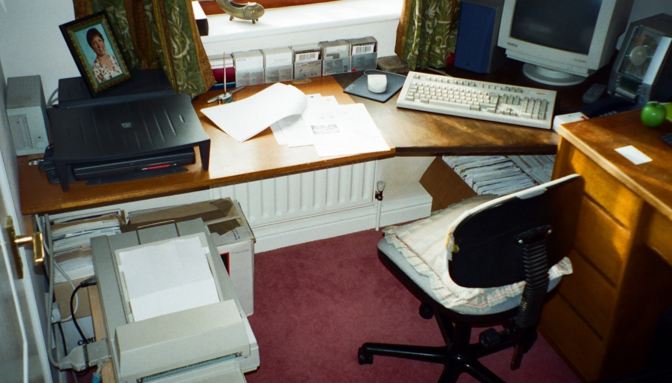

**1. Index Input Screen & Ref No Structure**

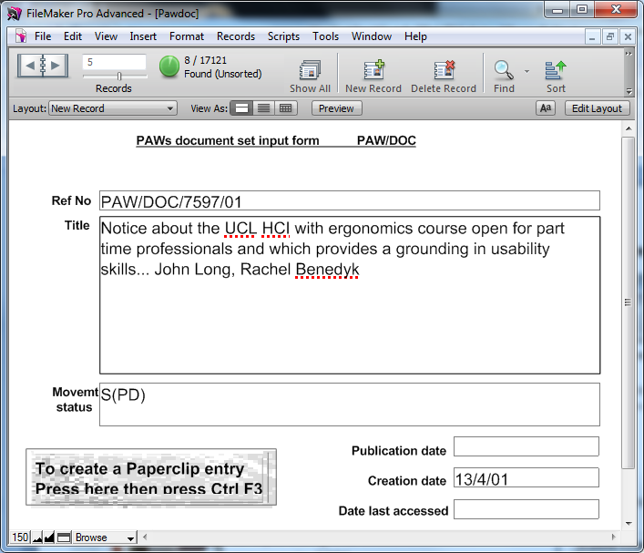

**4. The office in 1986 prior to converting the Index to a Filemaker database on the Mac in 1987**

