Specification for an RFID-based domestic loft management solution
1. Background
In 2004, the loft in the Wilson residence contained large quantities of a diverse range of materials placed and piled together in a very disorderly state. It was decided to organise the material using OFC (Order From Chaos) techniques and then to try to manage the contents using digital technology. The preferred approach was to use RFID or barcode systems to label each item and to control what was going in and out of the loft. However, the reader technology, at that time, was too expensive, and it was decided to simply number and photograph each item, and to record the items in a database. This system was employed successfully to manage a total of 341 items over a period of ten years.
In 2015, the Wilsons moved house, and the remaining items in the original loft were placed into the loft of the new house in no particular order together with a number of additional unnumbered items. One year later, it was realised that it was going to be necessary to reinstate some kind of a management system to be able to know what was in the loft and whereabouts it was stored. A quick search on the net established that RFID prices were now below £500 - within reach of the domestic householder - and could provide a solution for the loft in the new house. This document, therefore, seeks to define the requirements for an RFID-based loft management system based on an assessment of the operation of the system employed in the previous house.
2. Original system operated in the loft of the previous Wilson house
The original system was built around the construct of three different types of component – Positions, Items, and Containers. Positions were physical areas in the loft labelled with their own unique number, for example, P01. Items were the objects being stored, and Containers were objects in which Items or other Containers could be placed. Items and Containers were also each labelled with unique numbers, for example, I006 and C010. Items or Containers could be placed in a particular Position. An Item was required to either have a position or be in a Container. A Container was required to either have a Position or be in another Container. Note that a box containing many objects could be recorded as an overall Item rather than recording the box as a container and each object as an item in its own right. To do otherwise would have required far too much work for little reward – as in the case of the example shown in Figure 1.
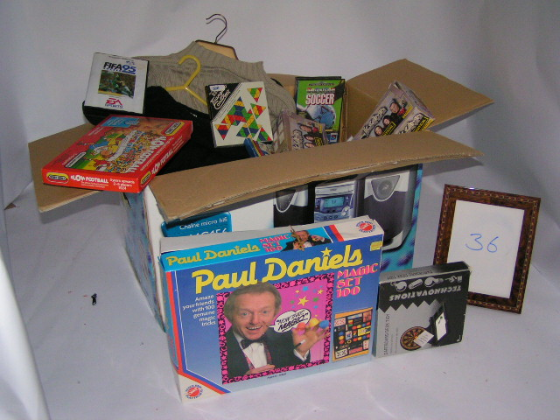
Figure 1 - Example of a box and its contents being defined as an Item
Each Position, Item and Container was photographed and the jpg file was labelled with the relevant unique number and a brief description – below are examples of each type:
Position 01 - Middle of wall at field end
Item 005 - Hamster Cage
Container 001 - Brown trunk
To ensure that the relevant number appeared clearly in the photos of Items and Containers, the number was either written on the flaps of cardboard boxes or on the glass front of a photo frame (which could subsequently be wiped and reused) as shown in Figure 2.
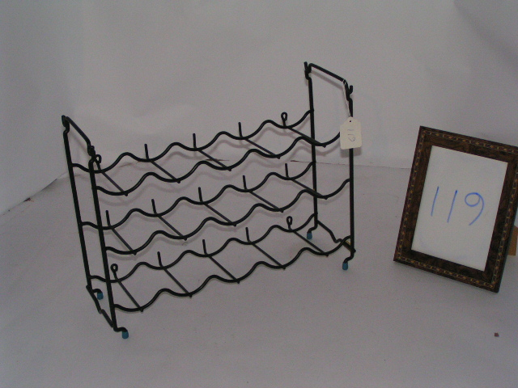
Figure 2 - Example of use of the glass front of a photo frame for displaying the number of an Item or Container being photographed
Positions were labelled by writing the number on a piece of paper using a wide-tipped felt tip pen, placing the paper in a re-sealable polythene bag and fixing the bag to an appropriate rafter using a drawing pin – as shown in Figure 3 below.
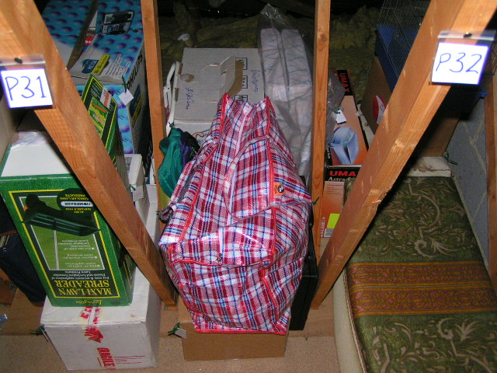
Figure 3 - Example of Position labelling

Items and Containers were labelled using white strung tags which are widely available in Stationery shops, as shown in Figure 4.
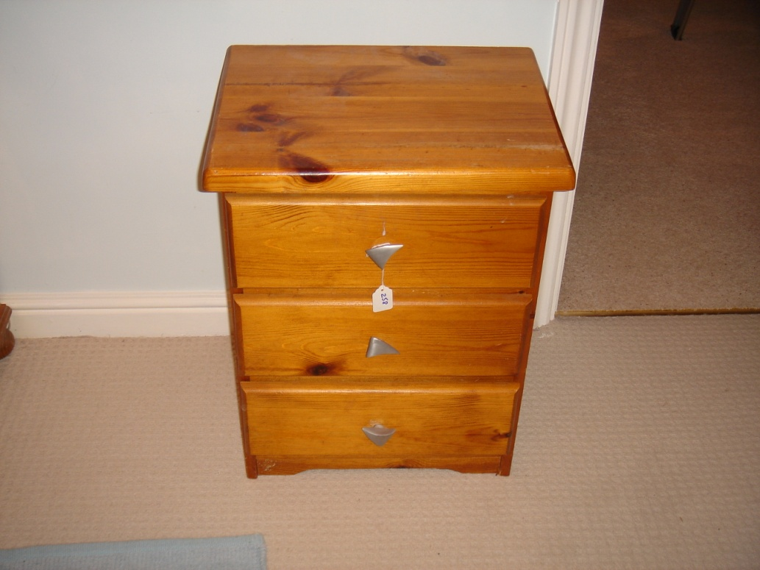
Figure 4 - Example of Item and Container labelling
Information about the Position, Container, Item and Change entities was held in a database built in the Filemaker database software product. The attributes defined for each of the entities are listed below:
Position: Number, Description, Image, Date Created.
Container: Number, Description, Image, Condition, Security Status, Date Created, Held in Container Number, Position Number.
Item: Number, Description, Category, Image, Owner, Condition, Value, Valuer, Date Created, Container Number, Position Number.
A fourth entity – Change – was added to manage the removal of items or containers from the loft, and for changes made to any of the attributes of the other entities. The attributes defined for the Change entity are listed below:
Change: Number, Date Change Record Created, Date Change Took Place, Type, Description, Item No, Container Number, Position Number, Person Who Made The Physical Change, Person Who Changed The Database.
The Condition Attribute had three possible values – Good, Fair and Poor.
The Security Status Attribute had three possible values – Open, Closed, Locked.
The Change Type Attribute had four possible values – Move, Modification, Removal, Replacement.
The values of the Category Attribute were derived over the life of the system as new items were added. The full list of Categories used in the system is shown below and gives a good indication of the diverse range of materials that the system had to deal with.
Categories Used in the System: Bags and Cases, Beach Stuff, Books, Bedding, Blinds and Curtaining, Camping and Trekking Equipment, Car Accessories, Car Boot Stuff, Christmas Decorations, Cloth and Soft Furnishings, Clothes, Collections, Computer Hardware and Software, Crockery, Decorating Materials, Dolls, Empty Boxes, Equipment, Flooring (carpet, lino etc.), Furniture, Games, Glassware, Hi-Fi & Video Equipment, Inscribed Trophies and Tankards, Jewellery, Kitchen Equipment, Lighting, Magazines, Magic Tricks, Music, Oddments, Ornaments, Painting Equipment, Papers and Files, Pet Equipment, Photos, Pictures, Sculpture, Shelving, Spares, Sports Equipment, Stamps, Stuffed Toys, Toys, Videos, Wiring and Plugs.
These categories need refinement as in at least two cases (Decorating Materials and Painting Equipment) duplication appears to have occurred. In this particular case, Painting Materials needs to be renamed as Artist’s Equipment.
The main interface to the database is shown in Figure 5.
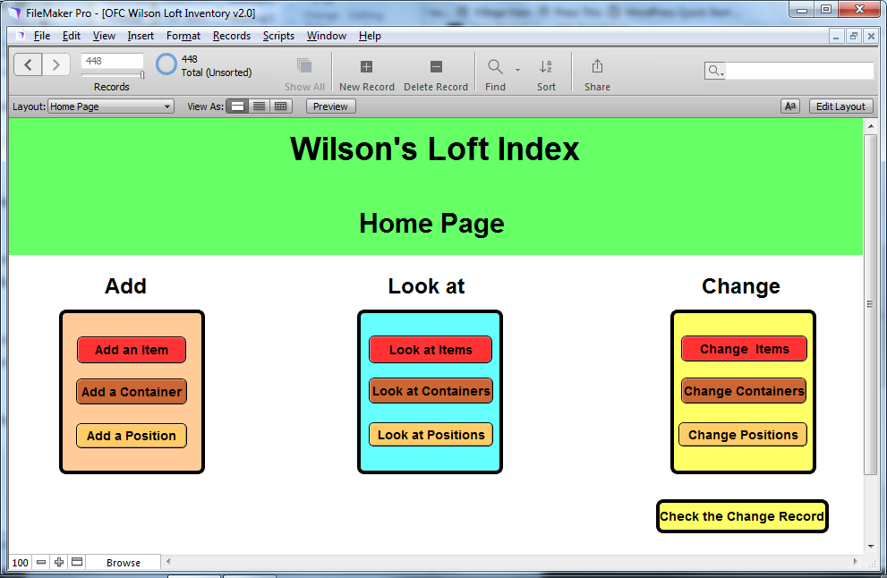
Figure 5 - The Main Interface to the Database
The process of introducing new Items to the system was refined over time. Initially, the process was:
- Assemble the item
- Make an entry in the database to establish the Item Number
- Label the Item
- Photograph the Item with the number written onto the glass front of the adjacent photo frame.
- Place the Item in the loft and note it’s position
- Complete the database entry by including the photo, recording its Position, and filling in the remaining empty attributes.
Photographing the item with its number figuring prominently in the photo was necessary when the database was being established and large numbers of items were being added all at once, to make it easier to associate each photos with the correct entry. However, after this point, when new items were being added individually or just a few at a time, it became much easier to match a photo with an database entry, and so the process eventually migrated to the following:
- Assemble the item
- Photograph the Item
- Make an entry in the database to establish the Item Number
- Label the Item
- Place the Item in the loft and note it’s position
- Complete the database entry by including the photo, recording its Position, and filling in the remaining empty attributes.
The photo file titles included the number of the Item/container in order to manage them as a collection in a folder and to ensure that the correct photo was associated with the appropriate database entry. Given this approach, the elimination of an Item/container’s number in its photo was perhaps no great loss – though having the number in the photo does actually provide the highest level of certainty about its veracity – provided the number in the photo was actually correct.
Removing Items from the loft or changing the contents or Position of an item, was more error prone than simply adding new items because there was less reason to access the database (for new items the database had to be accessed to establish their numbers). It relied on making notes of what had been changed, and then remembering to make the changes in the database. It was also particularly subject to error when other members of the family, who were not knowledgeable about or committed to the system, removed things from the loft. Similar processes applied to adding or changing Containers. Positions, however, were established at the initiation of the system and stayed the same throughout.
3. Successful aspects of the original system
The following aspects of the original system worked well:
- The construct of Items, Containers and Positions was able to address all eventualities.
- The physical labelling arrangements were reliable and effective.
- The addition of a photo to each database record made it very easy to visualise the objects concerned and to subsequently identify the physical objects in the loft.
- The ability to search for items in the database – particularly searches on the description attribute – was very useful in finding and rediscovering things in the loft.
- The list of loft contents printed out with photos and placed in a presentation folder, was very useful for those who were unfamiliar with, or did not have access to, the database (though, see its shortcomings in the next section).
4. Shortcomings of the original system
The original system had the following shortcomings:
- The change function in the database failed to automatically remove Items and Containers from Positions, and Items from Containers, when a ‘Remove’ change was specified.
- Items and Containers could be removed from the loft without the system being updated because, either, the person doing the removal failed to inform the manager of the system, or, the manager of the system failed to remember to update the system.
- The area of the loft used to store objects for car-booting became a hybrid area with some objects still being managed by the system and some not, as objects were added for future sales and the unsold objects from previous sales were returned and stored for a future sale.
- Large influxes of several items all at once, when offspring who had moved out required temporary storage for a variety of reasons, were hard to manage as they needed to be dealt with quickly (putting pressure on the methodical cataloguing, labelling and photographing process), and ideally the objects needed to be kept together in one area of the loft (which was difficult because usually there were no large empty areas available).
- The lack of a pre-defined View in the database which excluded those Items and Containers that had been removed from the system, made using the system a little more complex than it need have been.
- The loft contents list in a presentation folder soon got out of date and needed to be reproduced as objects were removed and added. The updating process was quite a big job as, at 6 items per page, it required over 40 colour pages to be printed and inserted into the presentation folder.
- The photos of the Positions were not taken when the Positions were empty – they were deliberately taken to include the actual Items and Containers that were initially stored there. However, as Items and Containers were added or removed, the photos became out of date.
- The Position labels were pinned to rafters and it was ambiguous as to whether they referred to the space to their left or to their right.
5. The target low cost RFID system
The low cost RFID system that has been identified is from a US company called uGrokit and is distributed in the UK by Codegate. The RFID reader/writer – called a Grokker – is designed to attach to iOS, Android and Windows smart devices via the headphone socket, and is able to write a unique 96-bit number on each RFID tag and then search for and find those tags in a six to ten foot range. The reader is powered by a rechargeable Li-Ion 1800mAh battery giving 1.5-2 hours active scanning. It uses standard a standard Micro-B USB charger which will deliver a full recharge in 2 hours (with 2.1 Amp supply). The reader sits underneath the phone and comes with a Silicone Retention Strap that enable it to be attached to most devices without the need to take that device out of its case or attach it permanently to the Grokker. When used with the band at the top of the smart device (closest to the “T” portion of the Grokker), this method of attachment allows the entire screen to be seen and will hold the device in place – see Figure 6.
Also provided with the uGrokit package is a database app (known as Discover Grok2) which can be downloaded for free from the app store and operated on IOS or Android phones or tablets. The app can be customised by adding additional Free Text or Value List fields into the database as required. The app is designed to interwork seamlessly with the camera on the smart device such that a photo can be taken from within the Discover Grok2 app and instantly stored in the Image field in the app. The database can be stored locally on the smart phone or shared among different devices by storing it on the uGrokit Cloud website (which is free for a limited but unspecified time).
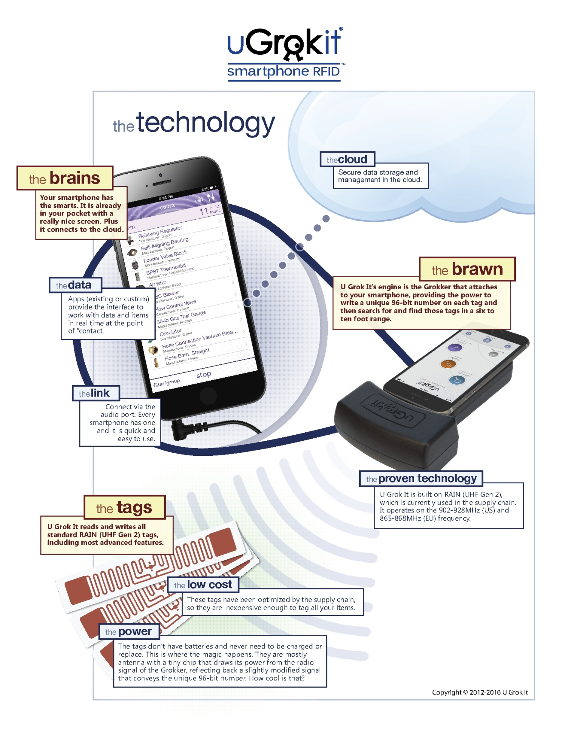
Figure 6 - The UGrokIt technology brochure
6. Possible differences between the previous system and an RFID-based system
Before redesigning the loft management system to make use of RFID technology, some thought was given to what might be the main differences between the previous system and an RFID-based system. The following points were noted:
- Under the old system it was possible to read the number on the paper labels of Items and Containers. Using RFID, Items and Containers would be labelled with stick-on RFID tags with no identification marks, and a Reader machine would be required to pick up the information from the tags.
- Under the old system it was possible to easily remove the labels on Items and Containers. It is not known how easily the stick-on RFID tags would be to remove.
- Under the old system the database was held on a laptop which was usually not in the loft and therefore not immediately accessible when looking at objects in the loft. Using RFID, the Reader needs to be connected to a Smart Phone which could store a version of the database and which could, therefore, be used when looking at objects in the loft. [Note that in recent years the old system could have employed a version of the database on a smart phone, but that development was never undertaken).
7. Design Considerations for four Use Cases
The design of an RFID-based system is explored below for four Use Cases: the movement of objects in and out of the loft; the finding of an object in the loft; the introduction of a new object to the system; and the removal of an object from the system.
7.1 The movement of objects in and out of the loft
In this Use Case, the main requirement is to record when a tagged object is either entering the loft or leaving the loft. The system must distinguish between these two different events. Design considerations include the following:
- To establish whether an item is going in and out of the loft, two readers would be required to determine the movement one way or another. Presumably, each reader would require its own smart phone. An alternative approach would be to use just one reader to detect movement around the loft hatch and then to deduce from the item’s database record whether the item is going in or out: if the record says it is in a Position in the loft then one can deduce it is coming out; and if the record says it has no Position in the loft one can deduce it is coming in. However, this arrangement would be prone to error if an item being moved around the loft came within range of the in-out reader. If a reader and smart phone were permanently in position they would either need to be permanently on or would need to be able to be switched on when detecting movement. In either case they would need to have constant power to charge them.
- If at least one reader and its associated smart phone is required to manage movement in and out of the loft, then either a minimum of two readers and smart phones would be required overall, or, somehow, the in-out reader would need to be able to be moved from its post to be used elsewhere for detecting items, setting up new items etc.
- It would be too costly to have even one reader and smart phone dedicated to managing the movement of items in and out of the loft.
- One possible approach which does not require a dedicated reader is to have two RFID tags near the Loft hatch – one signifying movement into the loft and the other signifying movement out of the loft. Then, after selecting the relevant item in the database the user could scan one or other of these RFID tags to record which action is being taken and to initiate the relevant fields being updated in the database.
- If it was decided to abandon the recording of movement in and out of the loft because it is too difficult or expensive to achieve, a completely different approach could rely on the ability of the reader to do an accurate stock check of what is in the loft at any one time, and then to deduce from that information what has been put in or taken out without recording the fact in the database.
7.2 The finding of an object in the loft
In this Use Case, the requirement is to be able to identify the Position Number of an Object in the loft so that the user can walk towards that area and then use the Reader to pinpoint the object itself. Design considerations include the following:
- Users need to be able to access the loft database to find Item/container Position Nos when they are either in the loft or outside the loft. This can be achieved by providing the database in one of three vehicle – a laptop, a smart phone, or on paper. Since the reader requires a smart phone to operate, using the uGrokit database app on a smart phone would seem to be the best solution.
7.3 The introduction of a new object to the system
In this Use Case, the requirement is to be able to create an entry in the database for the object, create an RFID tag linked to that database entry, fix the tag to the object, take a photograph of the object and store it in that database entry, place the object in a Position in the loft and record that Position in the database entry. All but the Positioning activities should be capable of being done either in or out of the loft. Design considerations include the following:
- In the previous system, photos of objects had to be transferred to the Windows laptop before being included in the database. In the new system, it would be most effective if the photos were taken with the smart phone and could be copied directly into the database residing on the smart phone. The uGrokit app has this ability .
- It might be useful to be able to record an Item’s Position by selecting the item in the database and then using the reader to scan the RFID tag of the Position it is in.
7.4 The removal of an object from the system
In this Use Case, the requirement is to find an object in the loft (see Use Case above) and then to take it out of the loft, deactivate its tag, and update the database entry to record that it has been removed from the system. No design considerations have been identified for this requirement.

8. Specification for the RFID-based system
- The system will be designed to operate initially with the Discover Grok2 app but without the uGrokit reader and RFID tags. However, the design will aim to minimise the effort required to convert to a full RFID-based system when the uGrokit reader is eventually obtained.
- The system will operate with the original construct of three main types of component – Positions, Containers, and Items– and the relationships between them as originally defined: Items or Containers can be placed in a particular Position; an Item must either have a position or be in a Container; and a Container must either have a Position or be in another Container.
- The Change entity will not be included. A ‘Date removed’ attribute will be added to the Container and Item entities to cater for when Containers and Items are removed from the loft; and changes to the descriptions of Container and Items will simply be recorded in free text in their description fields.
- The Position labels in their plastic wallets from the previous system will be re-used in the new system with the addition of arrows to show whether they refer to the space to their left or right when they are affixed to a rafter. If additional Position labels are required they will be created as necessary.
- Items and Containers carrying white string tags with numbers from the old system, will retain those paper tags and numbers in the new system. The numbering of new items and containers will start from the next number on from the highest number in the old system (i.e. 344 for Items and 72 for Containers). This will preclude any ambiguities relating to duplicate numbers.
- New images will be taken for all items and Containers because it is so easy to take a photo and get it into the Discover Grok app on the iphone. This will be much easier than trying to move photos of existing Items and Containers from the laptop.
- The following attributes will be defined for each main component:
- Position: Number, Description, Image, Date Created.
- Container: Number, Description, Image, Condition, Security Status, Date Created, Date Removed, Held in Container Number, Position Number.
- Item: Number, Description, Category, Image, Owner, Condition, Date Created, Date Removed, Held in Container Number, Position Number.
- The system will not attempt to automatically record movements in and out of the loft. Information about items and Containers going into the loft or coming out of the loft will be manually input to the Discover Grok database on an item by item basis.
- When a uGrokit reader is obtained, each item and Container will have an RFID tag attached in addition to their existing paper strung tag. New items will be given both an RFID tag and a numbered paper strung tag for an initial period while it is assessed whether the numbering system is a useful adjunct to the RFID system or not.

Paul Wilson
07Oct2016

