Roundsheet (streamlined version) Outline Specification
What is it? Roundsheet lets you think about things as a whole and as parts. Start off with the big picture then explore the parts [and then make your big picture part of a larger world – to b e provided]. [Expand your thinking across time or other dimensions – to be explored]. Ideas or numbers - Roundsheet works for both. For numbers and dates, Roundsheet builds in the concept of Planned Values and Actual Values.

Components and their representation
A. Basic Elements and their Graphics
B. Key Relationships
C. Names and Values
D. Actions
E. Graphic Transformations

A. Basic Elements and their Graphics
A1. The Round: A circle, possibly portrayed as a thin 3D cylinder slightly tilted. For example, a Round could represent the budget for a year, or the tasks in a project.

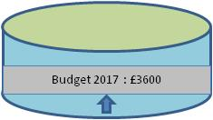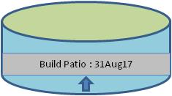

A2. The Slice: A subset of a Round as defined by two lines drawn from the centre of the Round out to its circumference. For example, a Slice could represent one of the main categories of expenditure in a budget, or one of the main activities in a project.

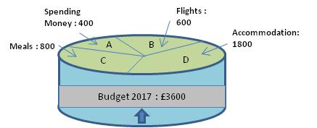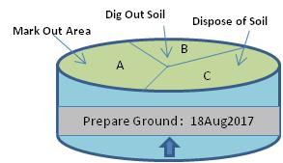

A3. The Stack: All the Slices in a Round can also be represented as a Stack of Slices underneath the Round. When the Stack is not being displayed, the arrow at the bottom of the Round is showing with the arrow pointing upwards. When the stack is being displayed the arrow at the bottom of the Round is showing with the arrow pointing downwards. The arrow can be toggled to point up or down by clicking on it.
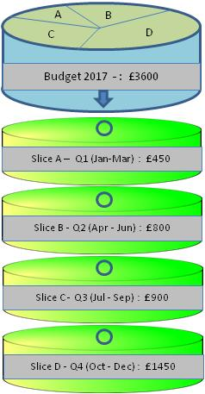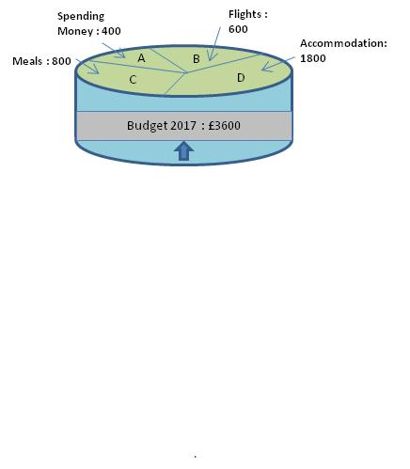

A4. The Roundsheet: A file containing at least one Round and any associated Slices.

B. Key Relationships
B1. One Round can have no slices at all or any number of Slices from two upwards.

B2. Each Slice can be transformed into, and worked upon, as a Round in its own right. When this transformation has occurred, it will be BOTH a Slice in connection with its parent Round AND a self-contained Round with or without Slices of its own (however, in practice, it’s not worth transforming a Slice into a Round unless the new Round is going to be given Slices). To display a Slice’s associated Round, click the unfilled circle in the relevant Slice in the Stack; while the Round is being displayed, the circle in the Slice will remain filled in. To hide the Round, click the filled-in circle and the Round will disappear and the circle will return to being unfilled.
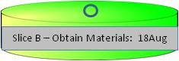

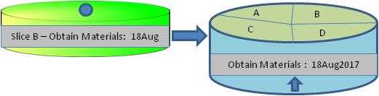
B3. Each Round can be transformed into a Slice belonging to another Round. When this has occurred, the Round will be BOTH a Round, perhaps with Slices of its own, AND a Slice in connection with its parent Round.
B4. All Rounds in a Roundsheet must be connected to each other by some lineage of Rounds and Slices; there cannot be more than 1 separate strand of Rounds and Slices in a single Roundsheet. This means that there can be two or more high level starting points for chains of Rounds and Slices but these must join into the main chain somewhere down the hierarchy.

B5. In summary, Rounds can be broken into any number of Slices, each of which can themselves be considered as Rounds in their own right with their own stack of Slices.
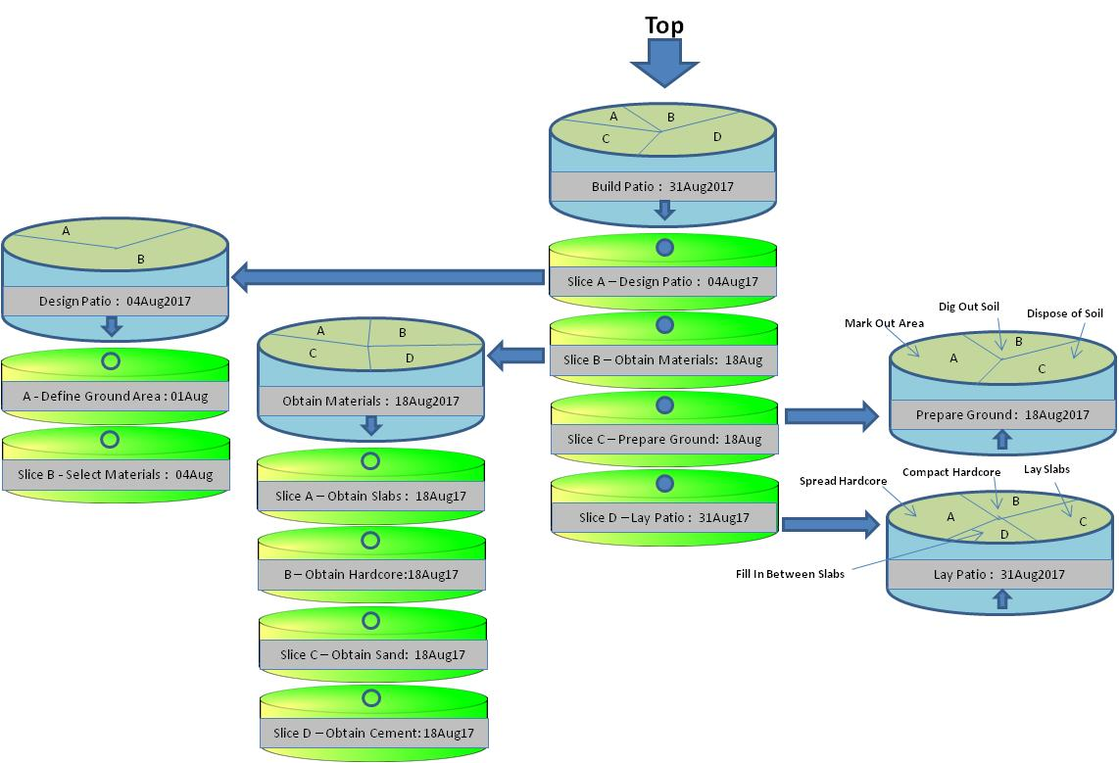

C. Names and Values (these would be better represented in a truth table)
C1. Roundsheets, Rounds, and Slices must have a name.

C2. Rounds and Slices can have a Value comprising a particular type of data.

C3. Data in Roundsheets can be Numerical, Date, Formulaic, Text or a File.
C4. Formulaic values are the system-calculated product of a formula pre-specified by the user, and can incorporate the values of other Rounds and Slices.
C5. Rounds and Slices that have Numerical or Date values can have just a Value, or a Planned Value and an Actual Value. The value calculations specified in C6 – C7 below apply to both Planned Values and Actual Values, though there is no relationship between Planned and Actual Values.
C6. A Slice has a numerical value if:
- the Round it is part of has a numerical value
- any of its fellow Slices in a Round already have a numerical value

C7. A Round has a numerical value if any of the Slices it contains have numerical values

C8. The same applies to C6-C7 for Date values.

D. Actions
D1. Create new Roundsheet: a) Open a window showing an empty Round with an empty field for its Name and another empty field for its Value (this should include a checklist for selecting the type of data as well as a space for specifying the actual value. If a Numerical or Date Data Type is selected, the user must also be asked to specify whether it is a Planned or an Actual value).

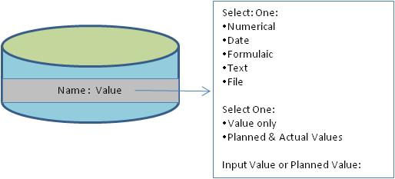

D2. Create new Round: Display an empty Round with an empty field for its Name and another empty field for its Value and proceed as specified in D1.
D3. Create new Slice (only available when a Round is selected): a) tilt the Round so that only the top circle is showing, b) display a dotted Slice line together with the proportionate numerical value of the Slice if a numerical value for the Round has been provided; c) ask the user to adjust the Slice lines to their desired positions; d) Request the user to specify a name and value for the new Slices created. N.B. If the Round has a numerical value, the overall value of the Round must remain the same unless the user actively changes it. Hence, when a new Slice is inserted into a Round with a numerical value, the values of the existing Slices must decrease. If the Round has a date value, the dates of the slices cannot be prior to the date of the Round.
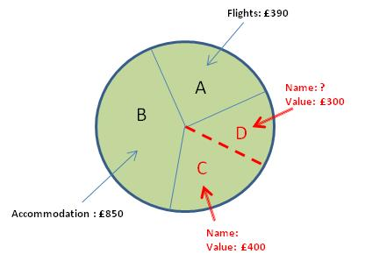

D4. View a Stack in Tabular form: Slices and Stacks can be viewed and worked in a more compact tabular form instead of the graphical format.

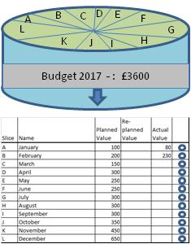

D5. Transform a Slice into a Round (only available when a Slice in the Round Stack is selected): a) display a new Round with the same name and value as the Slice it is related to; b) provide the user with a button which will engage the function to create a new Slice (see D3).

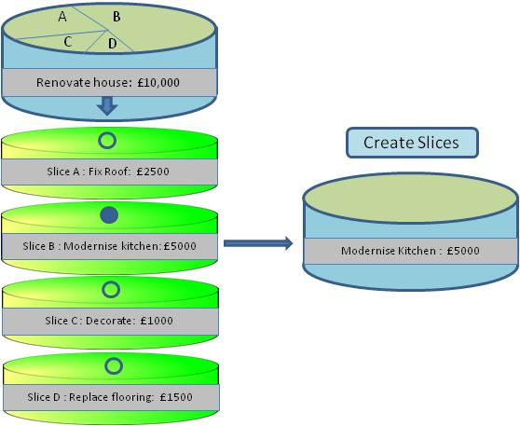

D6. View whole Roundsheet: All Rounds and Stacks are displayed in a compact form as illustrated below.

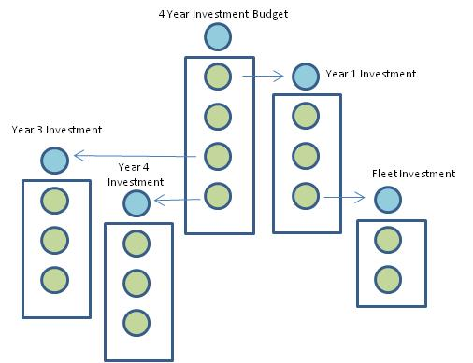

D7. Specify or change a Name: User performs by inserting the cursor in a Name field.
D8. Specify or change a Value: a) user performs by inserting cursor in a Value field; b) ensure that a Data Type is specified before a Value is inserted (if a Numerical or Date Data Type is selected, the user must also be asked to specify whether it is a Planned or an Actual value); c) check that the value is viable and if so permit it and if not indicate why it is not permissible.

E. Graphic Transformations (all to be reversible as appropriate)
E1. Whole Roundsheet to full display of a specific Round and it’s Stack: User clicks on a specific Round and the whole Roundsheet display is reduced in size and moved to the side; and the Round and Stack concerned are displayed to the right.

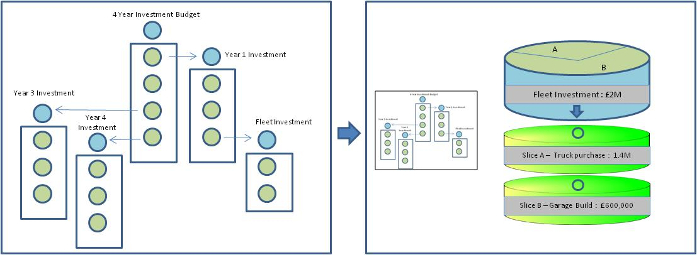

E2. Round without Stack displayed to Round with Stack displayed: User clicks on the upwards arrow in the Round and the Stack is displayed with the arrow in the Round showing as a downwards arrow.
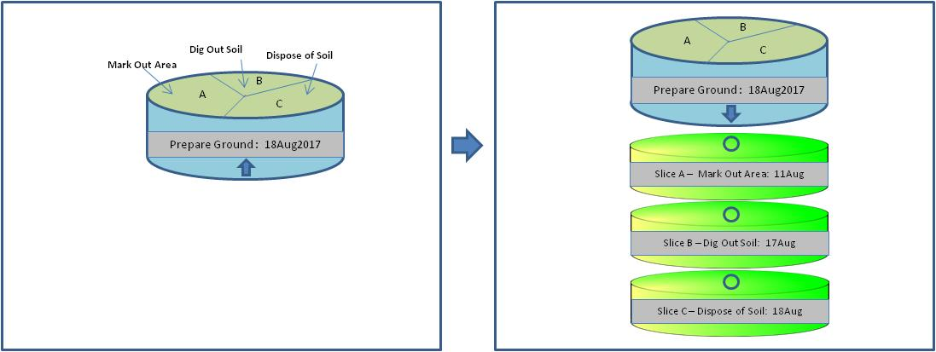

E3. Partial to full Round: User selects a ‘Create Slices’ button and the partially open faced Round is moved to the vertical to display a full circle Round in which the Slice lines can be adjusted.

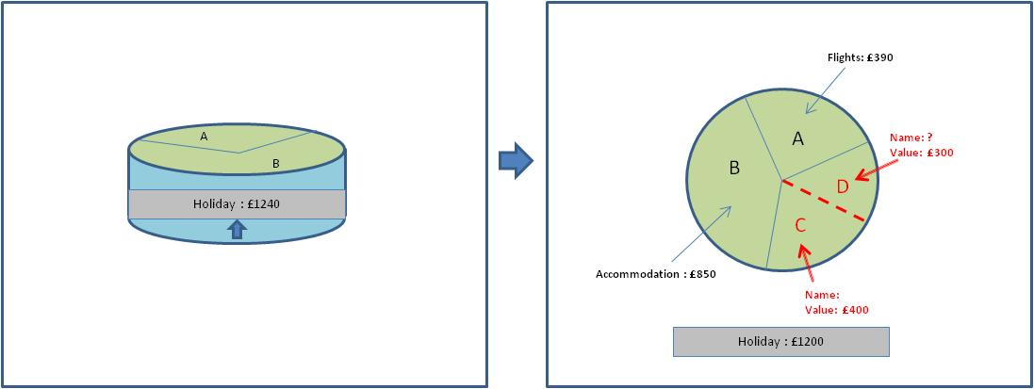

E4. Slice transforms to a Round: User clicks on the circle with no fill in a Slice in the Stack and a new Round with the same name and value as the Slice it is related to appears together with a ‘Create Slice’ button which can be selected. The circle in the Stack Slice now displays as a solid filled-in circle.
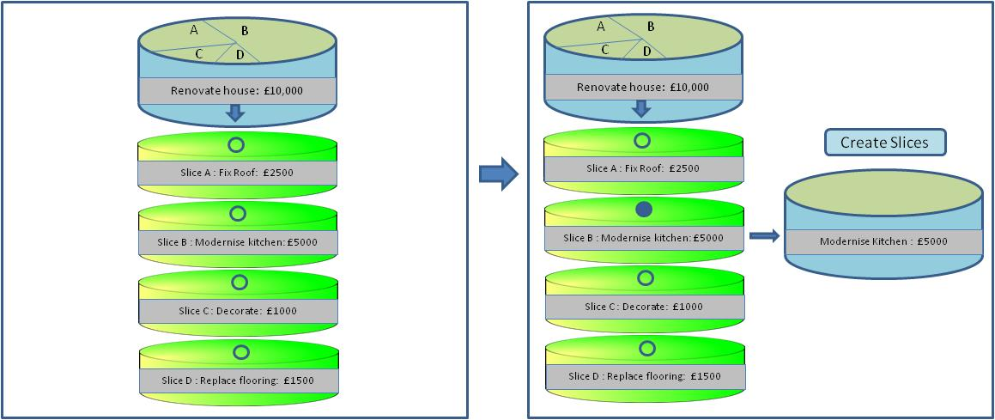
Uses
F. Example of Annual Budget
G. Example of a Plan to build a patio
H. Example of a filing index

F. Example of an Annual Budget

F1. Top level Round named Budget with a value of 1.2M
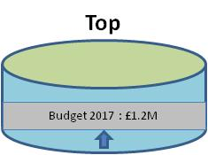

F2. Twelve Slices in the Budget Round, each Slice named one of the months of the year starting with January and ending with December.
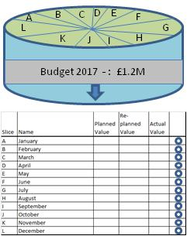
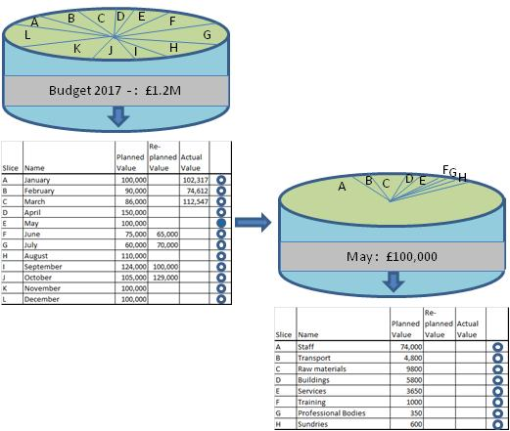
F3. All twelve Slices are transformed into Rounds, and each of these Rounds have Slices representing 8 types of expenditure, a Planned Value and an Actual Value. The January, February and March Rounds have Planned and Actual Values for all their Slices. The Slices in the other Rounds only have Planned Values. The January Round has a numerical Planned Value of 100,000 and an Actual Value of 102,317. The remaining month Rounds have varying values ranging from 60,000 to 130,000. The total Planned Values of all these month Rounds comes to the value of their parent Round - 1.2M

G. Example of a Plan to build a patio

G1. Top Level Round named Build Patio.
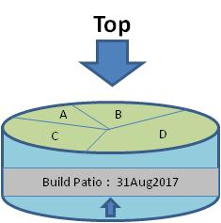

G2. Four Slices named respectively Design Patio, Obtain Materials, Prepare Ground, and Lay Patio; and each with a Planned Date – 4th August, 18th August, 18th August, 31st August – and Actual Dates (the Actual Dates are not shown in the graphical representation below). All of these Slices have been transformed into Rounds.

The Design Patio Round contains two Slices named respectively Define Ground Area, and Select Materials.

The Obtain Materials Slice has been transformed into a Round with four Slices named respectively Obtain Slabs, Obtain Hardcore, Obtain Sand, Obtain Cement.

The Prepare Ground Round has 3 Slices named respectively Mark out area, Dig out soil, Dispose of soil.

The Lay Patio Round has four Slices named respectively Spread hardcore, Compact hardcore, Lay Slabs, Fill in between slabs.

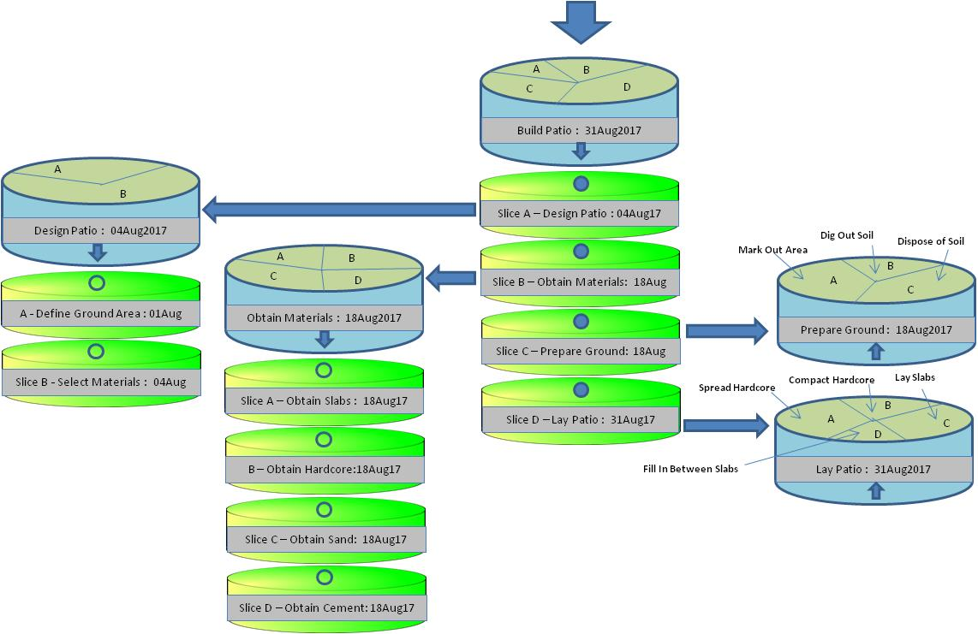
H. Example of a filing index

H1. Top Level Round named House Files Index.
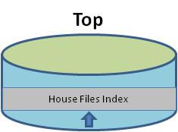

H2. 88 Slices named respectively House-001, House-002, House-003 and going up to House-088. All of these Slices have been transformed into Rounds with the same five Slices - Title, Keywords, Publication Date, Date of record creation, Files. All the Slices are populated with text or date values, apart from the final Slice (Files) which, in some of the Rounds, contains links to files.
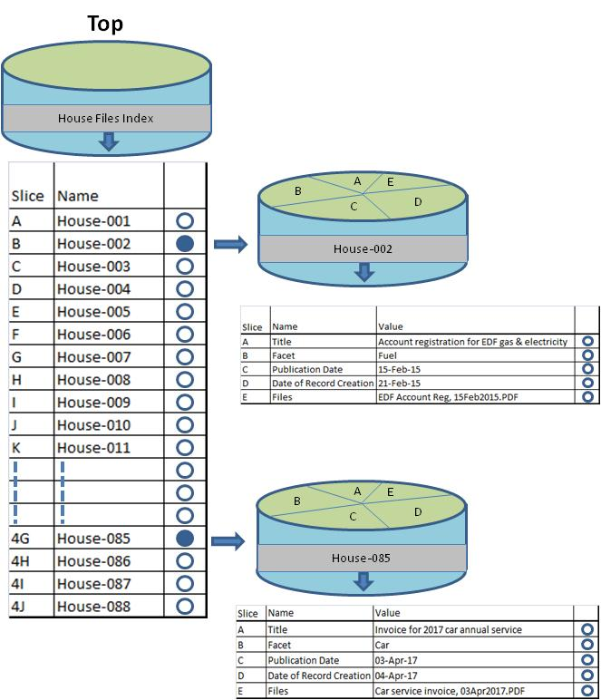

H3. To add another document, a new Slice is created in the top level Round using the next available serial number, for example, House-089. This new Slice is transformed into a Round with the five standard Slices (Title, Facet, Publication Date, Date of record creation, Files) which are populated with the relevant information for the new document.

Paul Wilson, 20Apr2017
=================================================================================
The name 'Roundsheet', and associated terms and functions which comprise and describe what Roundsheet is, are the copyright property of Paul Wilson, 2 Soames Close, Lavendon, Olney, Bucks, MK46 4EJ, UK from 29th May 1994. Should you intend to use these ideas I expect you to let me know; and should you sell a product based on these ideas I will expect to receive a 5% royalty from every instance and upgrade sold.

