Filemaker scripts built to test Filemaker AI features using the PAWDOC database

Script: Configure AI Account - LM Studio
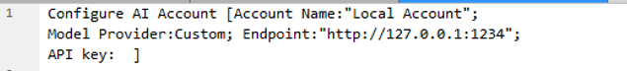

Script: Configure AI Account - Cohere
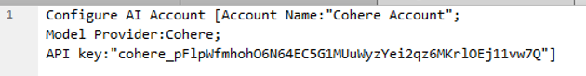

Script: Insert embedding in Found Set - LM Studio
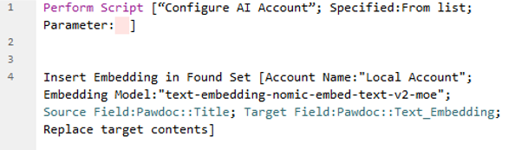

Script: Insert embedding in Found Set - Cohere
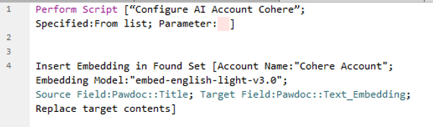

Script: Perform Semantic Search – LM Studio
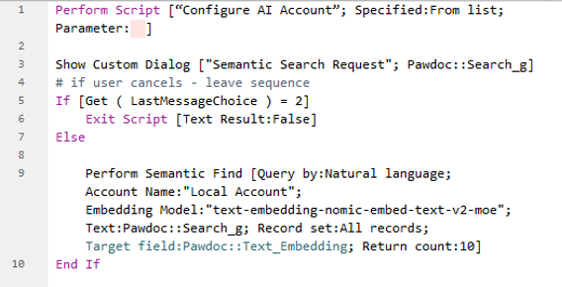

Script: Perform Semantic Search – Cohere
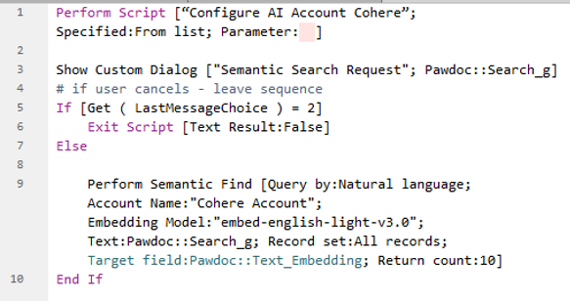

Script: Perform Hybrid Search – LM Studio
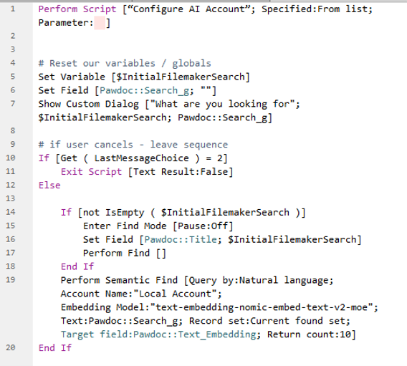

Script: Perform Hybrid Search – Cohere
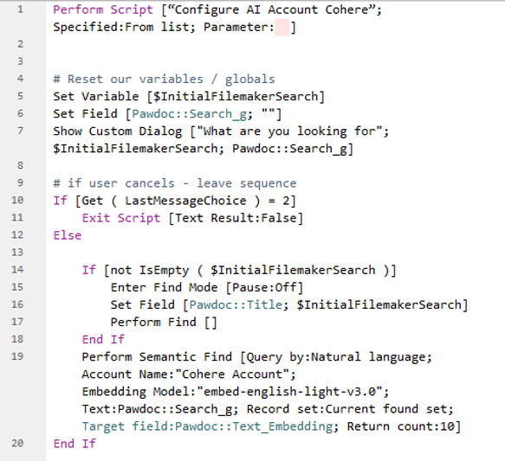
Script: Find by Natural Language – LM Studio
